

Enterprise ERP
User Guide for
Vendor Self Service (VSS)
______________________________________________________
Version 2024

TABLE OF CONTENTS
Vendor Self Service Overview 3
Vendor Self Service and Tyler Identity 4
New Users 4
Existing Users 6
Password Resets 6
Locked Accounts 6
Vendor Registration 7
Linking to an Existing Enterprise ERP Vendor Record 8
Creating a New Vendor Record 9
Company Information 10
Vendor Address 11
Minority Business Enterprise 12
Federal Tax ID Number or Social Security Number, Payment Terms, and Bank Information 13
Vendor Self Service 22
Vendor Information 24
Attachments 26
Commodities 28
1099 30
Bids 31
Checks 36
Invoices 38
Purchase Orders 41
Contracts 43
Work Orders 45
Appendix A—Managing Minority Business Enterprise Certificates 46
Appendix B—Using Vendor PIN Authentication 51

Vendor Self Service Overview
Vendor Self Service (VSS) provides vendors with web-based access to information stored in Livingston Parish Public School’s Enterprise ERP database. The information is drawn from multiple Enterprise ERP products, including Accounts Payable, Purchasing, Contract Management, Bid Management, and Asset Management.

Using VSS, vendors can enter and maintain their contact and remittance information, discount and payment terms, designated contact persons, and the commodity codes that represent the goods and services the vendor can provide.

A listing of the vendor’s current and prior 1099 data, purchase orders, invoices, contracts, checks, and work orders is available in VSS. This information is entered by Livingston Parish Public Schools (LPPS) using Enterprise ERP programs, and the information is available to vendors for inquiry purposes only.

VSS allows vendors to search for and view bid request information, and then use that information to submit a bid offer or quote. The submission process creates bid records in the Enterprise ERP database that can be examined and evaluated by LPPS’s bid management personnel.

Vendor Self Service and Tyler Identity
Vendors must have an email address associated with a Tyler Identity account. Tyler Identity is used by multiple Tyler applications, including Vendor Self Service and Citizen Self Service, to provide users a single sign-on experience. The log-in account requires a unique email address and password.

New Users
To associate an email account with Tyler Identity, open the VSS application and click Log In to access the Tyler Identity log-in screen.
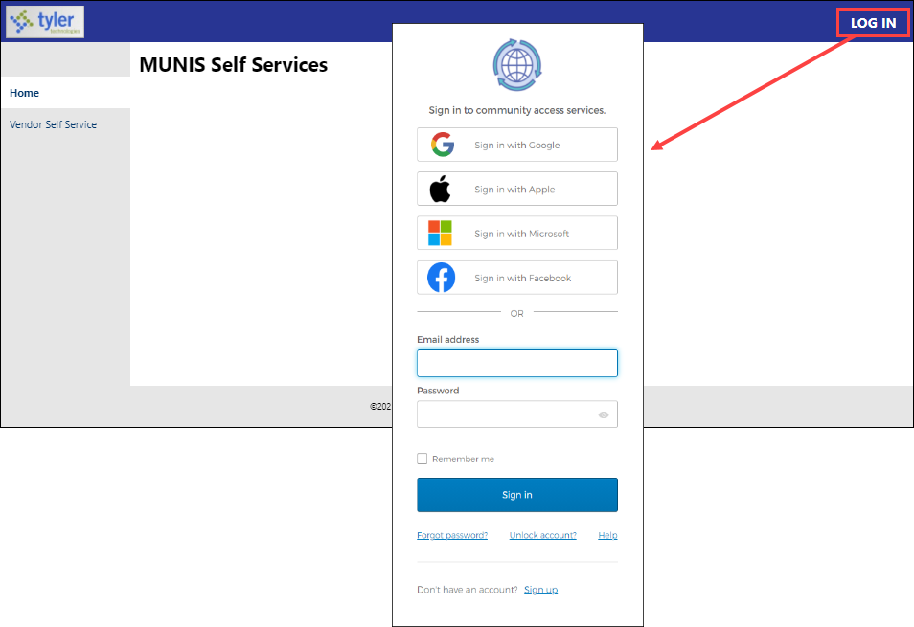

From this screen, vendors may use their established email and password credentials for an existing social account (such as Google®, Apple®, Microsoft®, or Facebook®) to log in, or click the Sign Up option to create unique Tyler Identity credentials.
To create unique Tyler Identity credentials, click Sign Up to display the Create an Account screen.
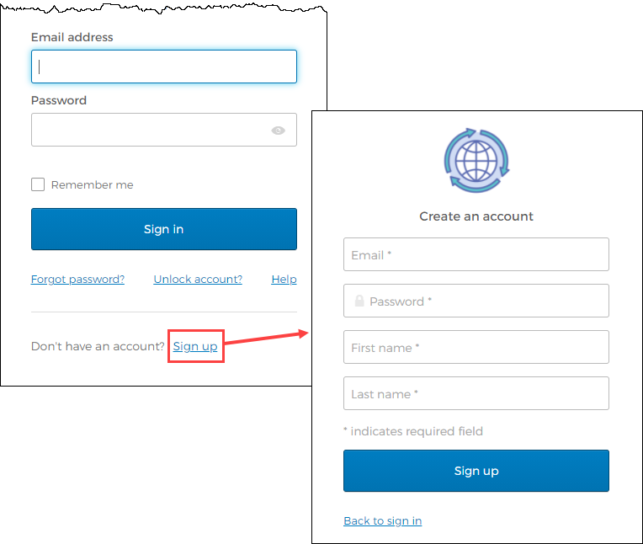
Enter a valid email address, create a password, complete the first and last name information, and click Sign Up. Tyler Identity sends a verification email to the supplied email address.
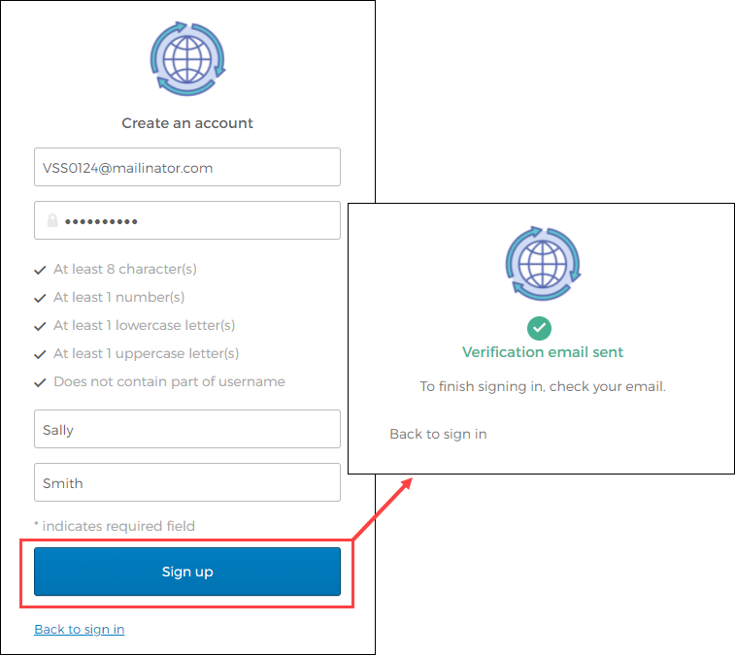
Click the link in the verification email to complete the account verification process and return to VSS. Users cannot log in to VSS until they verify the account.

Existing Users
Users who have established a Tyler Identity account can log in using their Tyler Identity email and password credentials. Users who have not transitioned to using Tyler Identity must create a new account.
- If vendors create a Tyler Identity account using their previous credentials and the email addresses match, the existing VSS account information is automatically linked to the Tyler Identity account.
- If vendors do not use an existing email, or if they have multiple accounts that use the same email address, they must create a new Tyler Identity account and complete the process to link the VSS account to it.

Important! Tyler Identity allows users to log in using social provider accounts such as Apple, Facebook, Google, and Microsoft. The email address associated with the social provider account is used as the Tyler Identity email when completing these account verifications.

Password Resets
If a user forgets their assigned password, clicking the Forgot Password? link on the Sign-in screen provides the steps to reset the password. The Help link on the Sign-In screen also provides detailed password retrieval instructions.
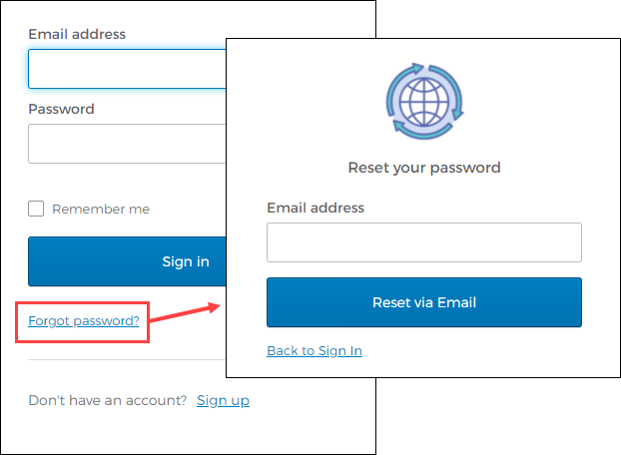

Locked Accounts
If a user's account is locked, for example, if too many unsuccessful password attempts have been made, clicking the Unlock Account? link on the Sign-in screen provides the steps to unlock the account. Enter the email address associated with the account to begin the process to unlock the account.
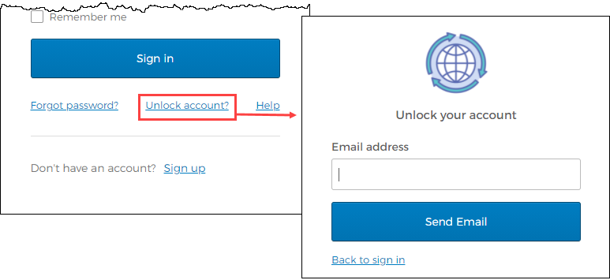

Vendor Registration
Vendor Self Service requires vendors who exist in the LPPS Enterprise ERP database to register using the VSS website to gain access to their information. To successfully link a vendor’s VSS registration with a record in Enterprise ERP, LPPS must provide the vendor with the vendor ID number assigned by LPPS. The vendor enters the number in the Vendor ID box during registration.

Potential vendors who do not exist in the LPPS Enterprise ERP database can complete the registration process, but they are granted limited access to VSS. When completed by a potential vendor, the registration process creates a new record in the Vendors program in Enterprise ERP. LPPS must change the status of the newly created record to Active in Enterprise ERP and grant the vendor’s user ID access to the appropriate pages in VSS before the vendor can fully utilize the site.

Once the vendor successfully logs in to VSS, the program provides the Vendor Self Service Home page. This page includes options to create a new vendor record or link to an existing Enterprise ERP vendor record.
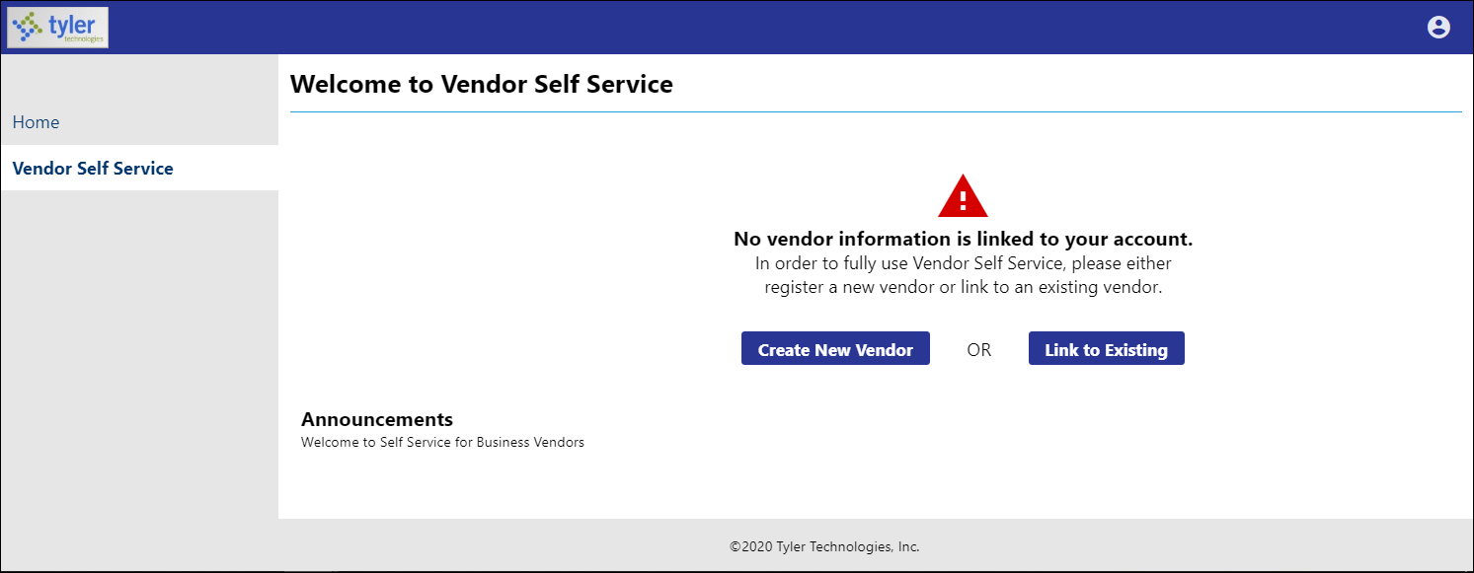

Linking to an Existing Enterprise ERP Vendor Record
If the vendor has an existing record in the Enterprise ERP Vendors program, the Link to Existing option provides the Link to Existing Vendor screen, where you can enter the vendor number and the vendor's federal identifier or Social Security number to search for the existing vendor record.
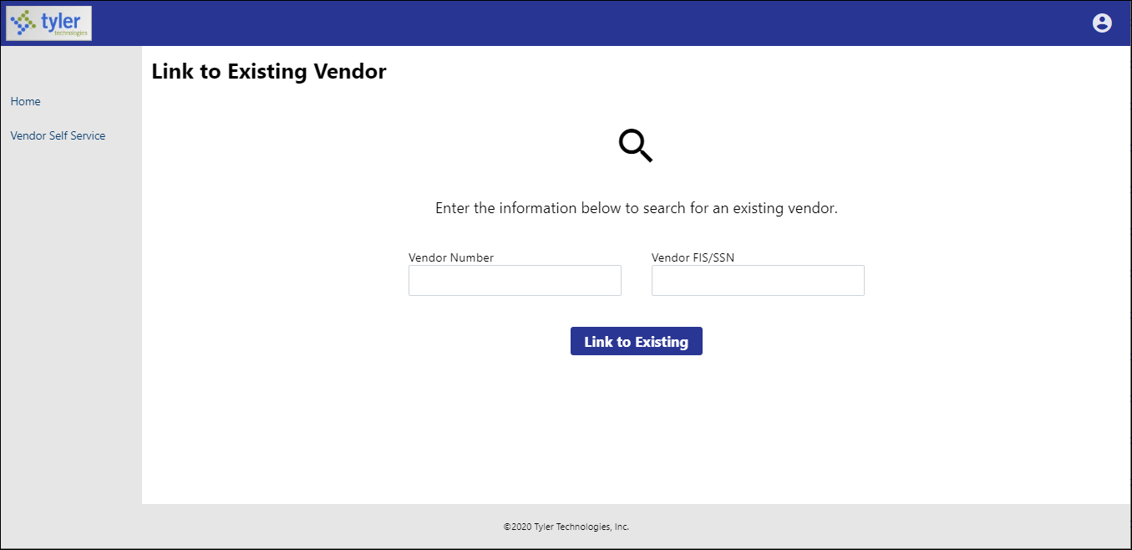
When existing Enterprise ERP vendors complete the Vendor Number and Vendor FIS/SSN boxes and click Link to Existing, VSS verifies the entered information with the vendor record in Enterprise ERP. If all information matches, the vendor is automatically presented with the Vendor Information page. They do not have to complete the remaining steps of the registration process. However, in order to complete the process successfully, the vendor must know the Enterprise ERP vendor ID assigned by LPPS, which is the vendor number in the Enterprise ERP Vendors program. The value entered in the Vendor FIS/SSN box must match the value from the Enterprise ERP vendor record exactly.

Creating a New Vendor Record
If the vendor does not have an existing record in the Vendors program in Enterprise ERP Accounts Payable, the Create New Vendor option provides Step 1 of the New Vendor Registration screen.
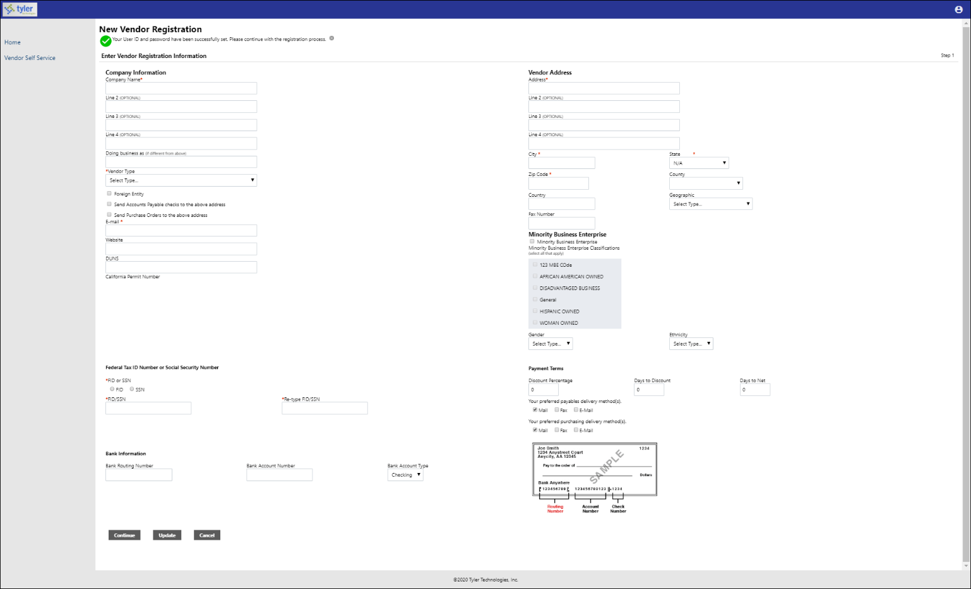

Vendors must complete the required fields to specify the information for the new vendor record.

Company Information
The Company Information group of the New Vendor Registration page defines basic information about the vendor.
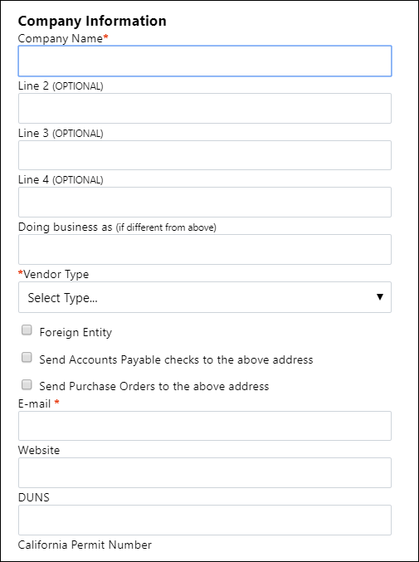

Field | Description
Company Information
Company Name | Contains the vendor’s name or business name.
Line 2  Line 3  Line 4 | Stores additional vendor name or business name information, such as an address.  These fields are optional.
Doing Business As (If Different from Above) | Indicates the vendor’s doing business as (DBA) name, if applicable.
Vendor Type | Sets the type code for the vendor.
Foreign Entity | When selected, indicates that the vendor is a foreign entity.
Send Accounts Payable Checks to the Above Address | When selected, sends accounts payable (AP) checks to the address indicated on the previous lines in the Company Information group rather than the address in the Vendor Address group.
Send Purchase Orders to the Above Address | When selected, sends purchase orders (POs) to the address indicated on the previous lines in the Company Information group rather than the address in the Vendor Address group.
Email | Contains the vendor’s primary email address. It is the address to which all notifications and alerts are sent, such as registration confirmation messages or password hints.  Additional email addresses for vendor contacts are defined later in the registration process.
Website | Includes the URL for the vendor’s website.
DUNS | Indicates the 9-digit Data Universal Numbering System (DUNS) number assigned to the vendor organization.  The DUNS number is a unique 9-character identification number provided by Dun & Bradstreet (D&B). The DUNS number is used by the federal government to monitor business entities. A DUNS number is required for federal grants and proposals.
California Permit Number | Identifies the permit number for vendors who do business in California.

Vendor Address
The Vendor Address group of the New Vendor Registration page specifies the vendor's main address and selected contact information.
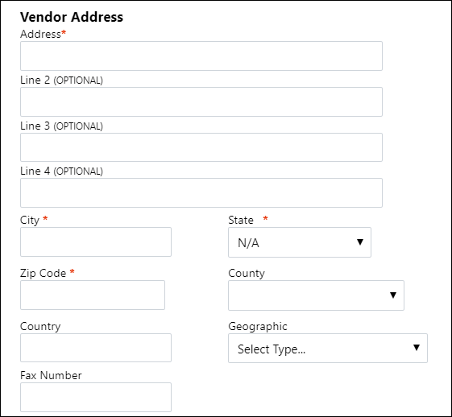

Field | Description
Vendor Address
Address  Line 2  Line 3  Line 4 | Define the vendor’s main address.
City | Specifies the city portion of the vendor's address.
State | Establishes the state portion of the vendor's address. The vendor must enter a two-letter state postal abbreviation code in this box.
Zip Code | Contains the ZIP CodeTM portion of the vendor's address.
County | Identifies the county portion of the vendor's address, if applicable. This information may be relevant if the vendor resides in a county that collects county-specific sales tax.
Country | Sets the country for addresses that are outside of the United States.
Geographic | Indicates the vendor’s geographic code.
Fax Number | Displays the vendor’s fax number, if applicable.

Minority Business Enterprise
The New Vendor Registration page contains a Minority Business Entity (MBE) section that must be completed by vendors that are designated as minority business enterprises. A minority business enterprise is typically defined as a business that is at least 51% owned and operated by a minority. These businesses are typically certified by a city, state, or federal agency.
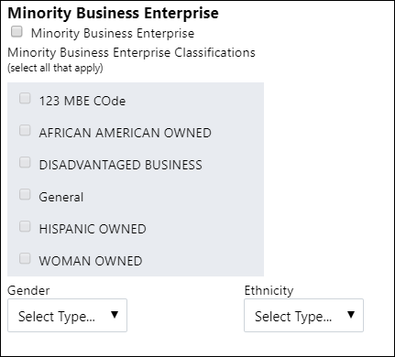

Field | Description
Minority Business Enterprise
Minority Business Enterprise | Indicates that the vendor is a minority business enterprise, when selected.
Minority Business Enterprise Classifications (Select All That Apply) | Define which MBE classifications the vendor possesses. The vendor can select one or more of the check boxes, but the General check box is always selected and cannot be cleared.  The MBE Classifications section displays the number of certifications of each type that the vendor possesses.
Gender  Ethnicity | Contains the vendor gender and ethnicity codes for vendor statistic and tracking purposes.

Federal Tax ID Number or Social Security Number, Payment Terms, and Bank Information
The groups at the bottom of the New Vendor Registration page specify tax, payment, and banking information for the vendor. The FID or SSN must be a unique value that is not used by any other vendor profile, unless your organization has selected the Allow Duplicate FIDs/SSNs check box in the Accounts Payable program.
The Bank Information section does not display unless your VSS administrator has enabled entry of bank information on this page.
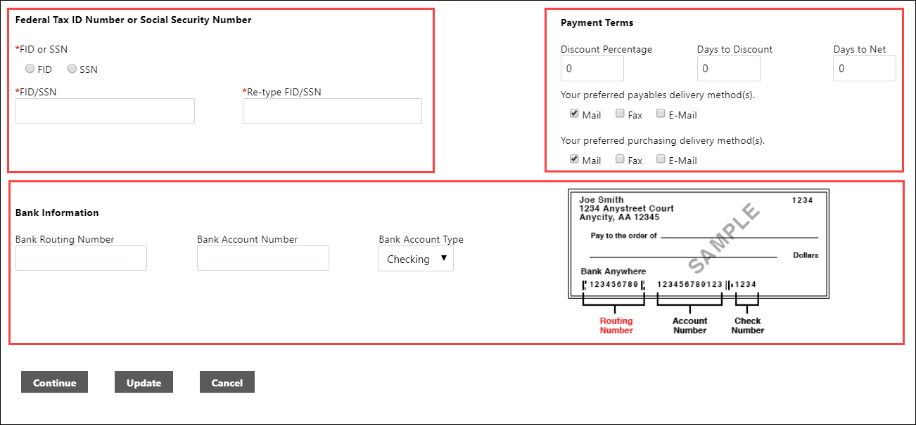

Field | Description
Federal Tax ID Number or Social Security Number
(The fields in this group are all required.)
FID or SSN | Requires the vendor to select whether to enter a federal tax identification number or a Social Security number.
FID/SSN | Identifies the vendor's federal tax identification number or Social Security number.  If SSN is selected, the Social Security number must be entered in the format nnn-nn-nnnn.
Re-type FID/SSN | Provides space to re-enter the vendor's FID or SSN to confirm the correct value.
Payment Terms
Discount Percentage | Defines the discount percentage the vendor extends to your organization.
Days to Discount | Contains the number of days within which payment must be received by the vendor in order for your organization to claim the discount percentage.
Days to Net | Indicates the number of days that the vendor allows before requiring net payment.
Your Preferred Payables Delivery Method  Your Preferred Purchasing Delivery Method | Determine the vendor’s preferred delivery method for payables and purchasing documents.

Bank Information
Bank Routing Number | Determines the routing number of the bank account to which payments made to the vendor should be sent. The program automatically selects the correct bank code based on the entered routing number.
Bank Account Number | Contains the vendor’s bank account number.
Bank Account Type | Indicates the type for the entered account: checking or savings.

Click Continue to progress to Step 2 on the New Vendor Registration page.
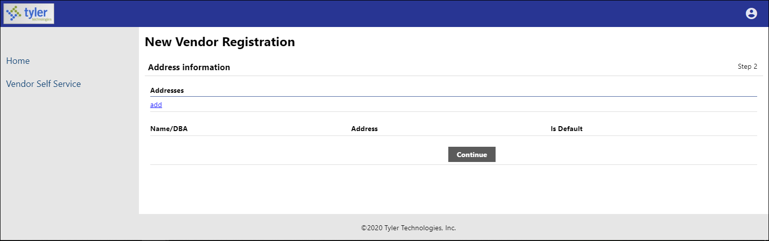
Click the Add link in the Addresses group to display the General Vendor Contacts screen for adding vendor remit address information.
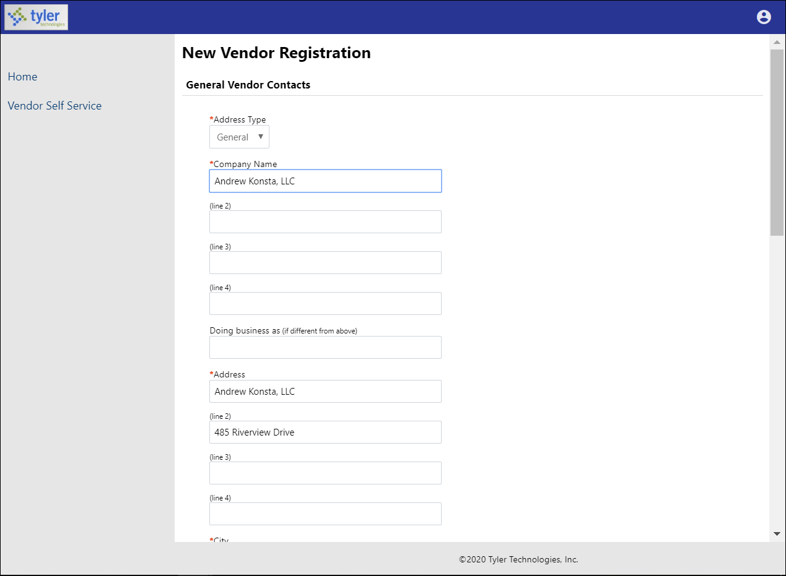
After completing the fields, click Save at the bottom of the page. VSS saves the entered information and returns to the Step 2 screen, summarizing the entered information.
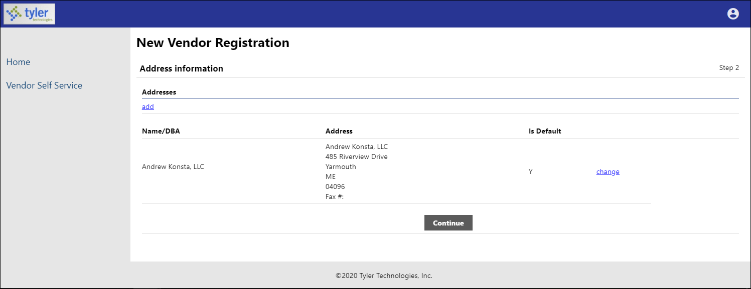
Click Continue to progress to the Step 3 screen for defining vendor contacts.
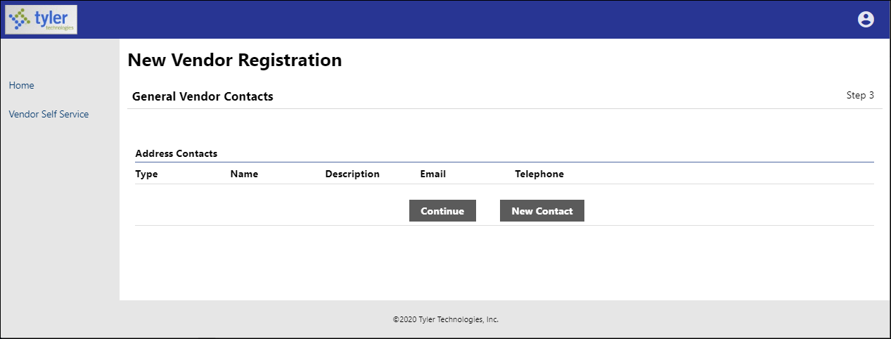
Click New Contact to add a new vendor contact.
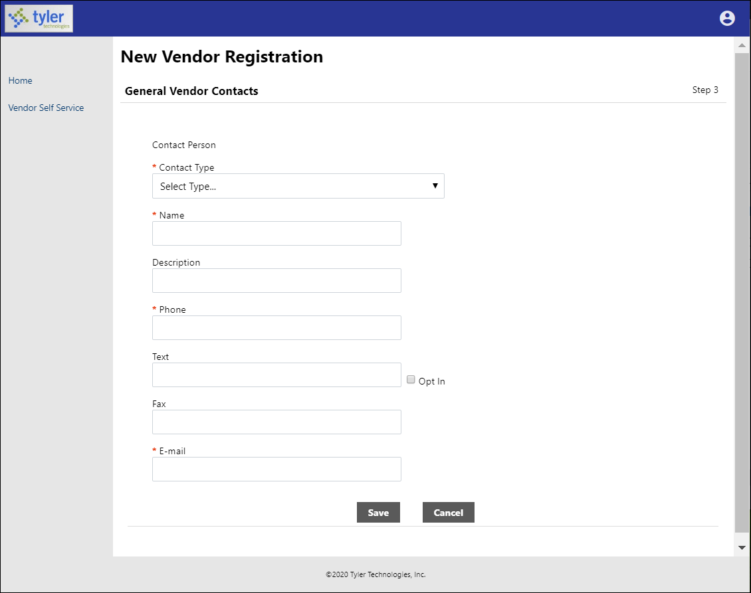
Complete the fields and click Save. VSS saves the entered information and returns to the Step 3 screen, summarizing the entered information.
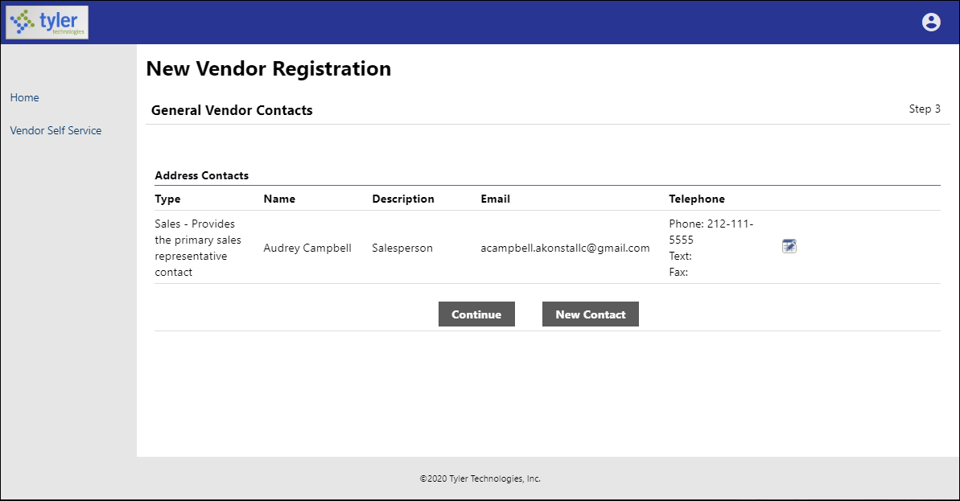
Click Continue to progress to the Step 4 screen.
In this example, the Step 4 screen provides additional values to specify for the vendor, such as a preferred shipping vendor.
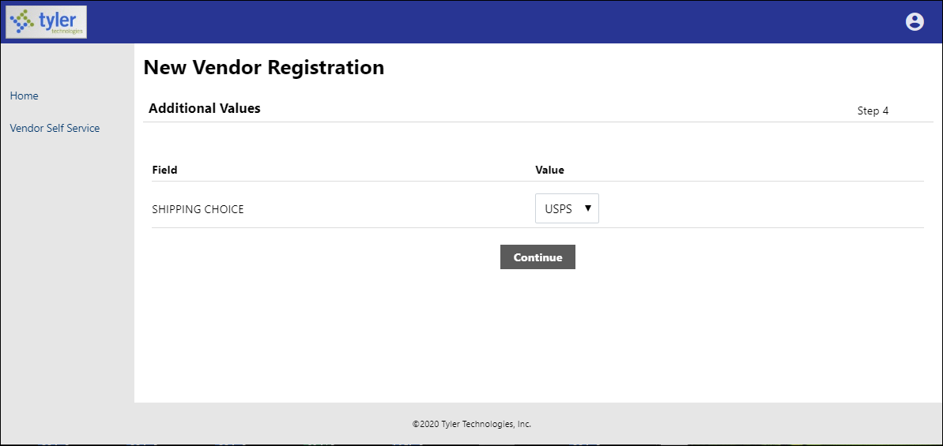
Select the additional values as required and then click Continue to progress to the Step 5 screen. In this example, VSS provides the Select Commodities screen for choosing the commodity codes to associate with the vendor.
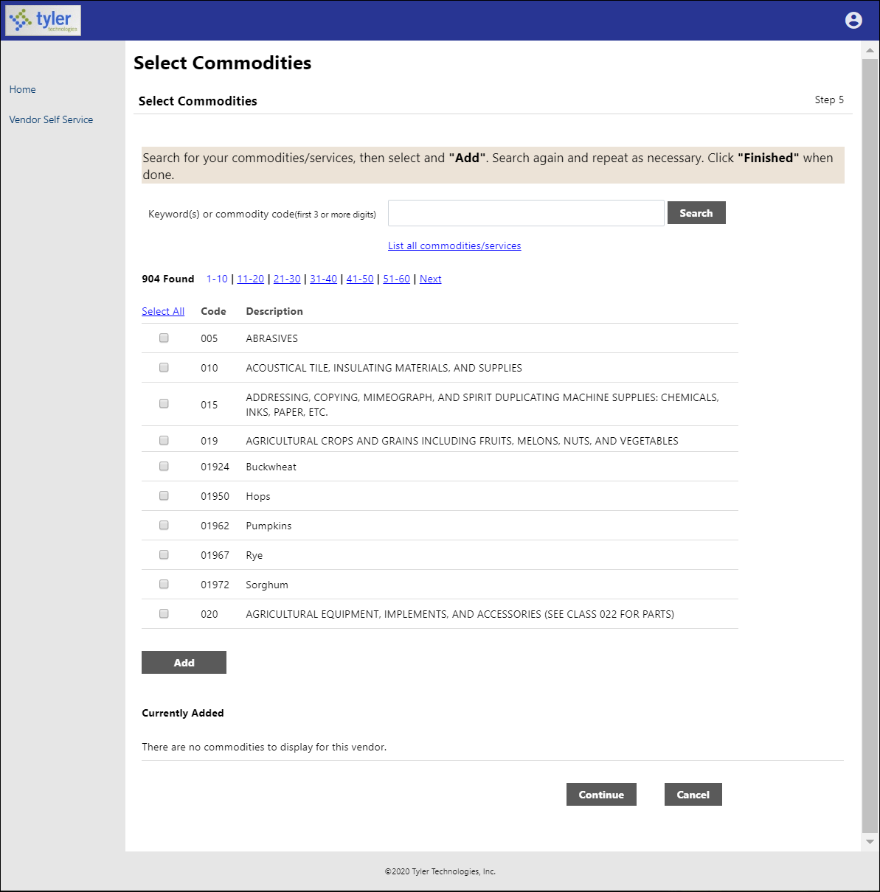
Enter keywords or commodity codes in the Search box to refine the list of provided codes.
Select the check box for each commodity code to associate with the vendor, and click Add to associate the selected commodity codes with the vendor.
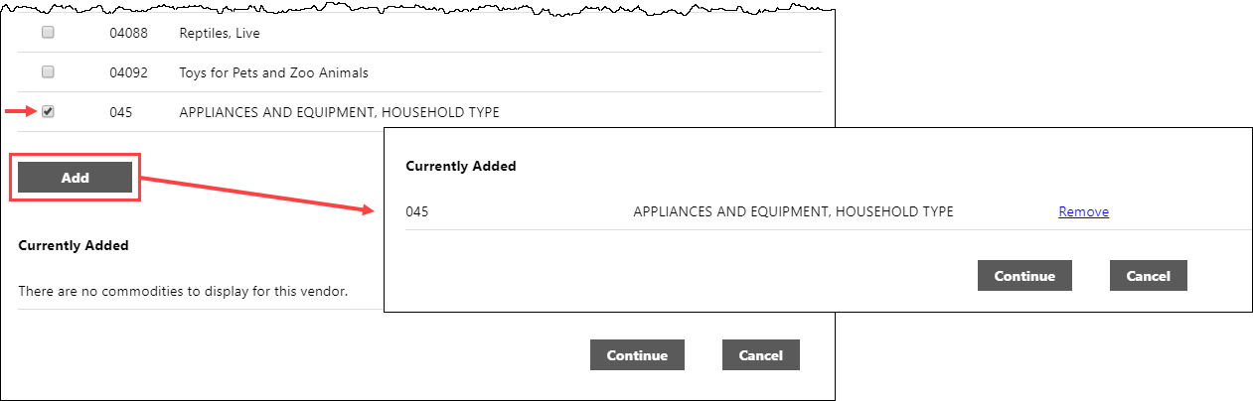
Use the Remove option to delete any currently associated commodity codes.Click Continue to progress to the next step to review the entered information prior to submitting the vendor registration.
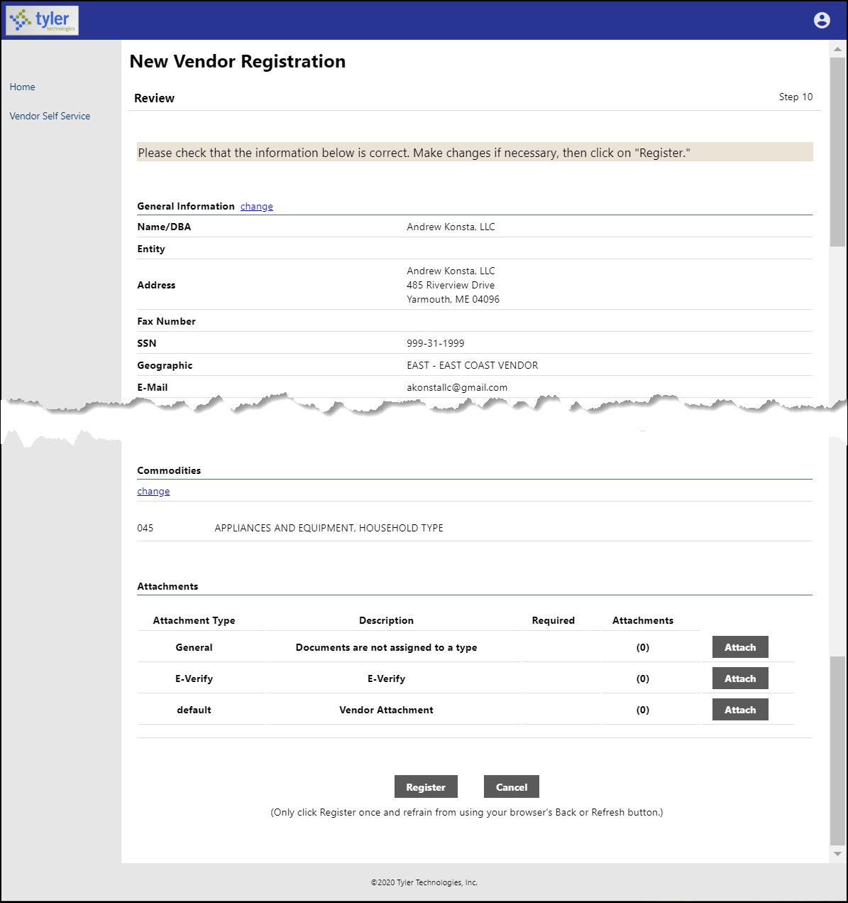
Click Register to complete the registration. You must click the Register option only once and remain on the page. If the registration is successful, VSS provides a Registration Confirmation page.
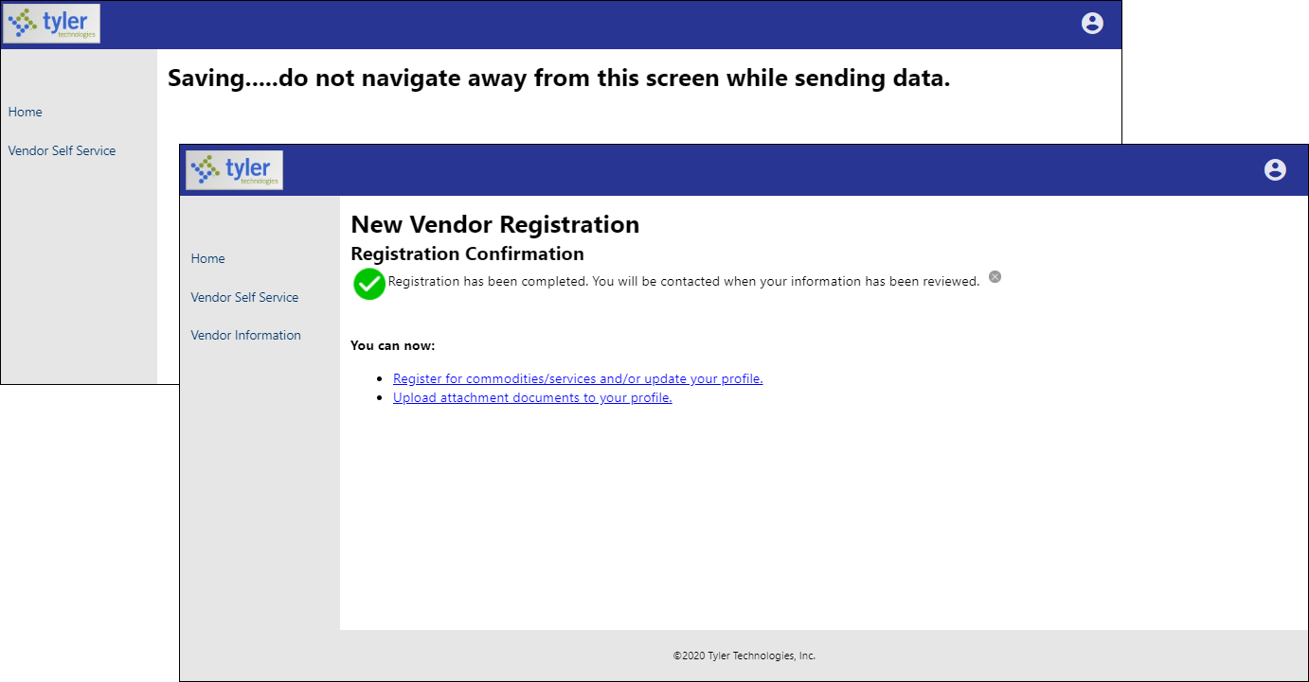
Newly registered vendors only have access to the Home, Vendor Self Service, and Vendor Information tabs. LPPS must grant the vendor access to additional options.

Vendor Self Service
The Vendor Self Service home page provides the vendor’s profile information and access to the options that LPPS makes available, such as Invoices, Checks, Purchase Orders, Contracts, and Bids.
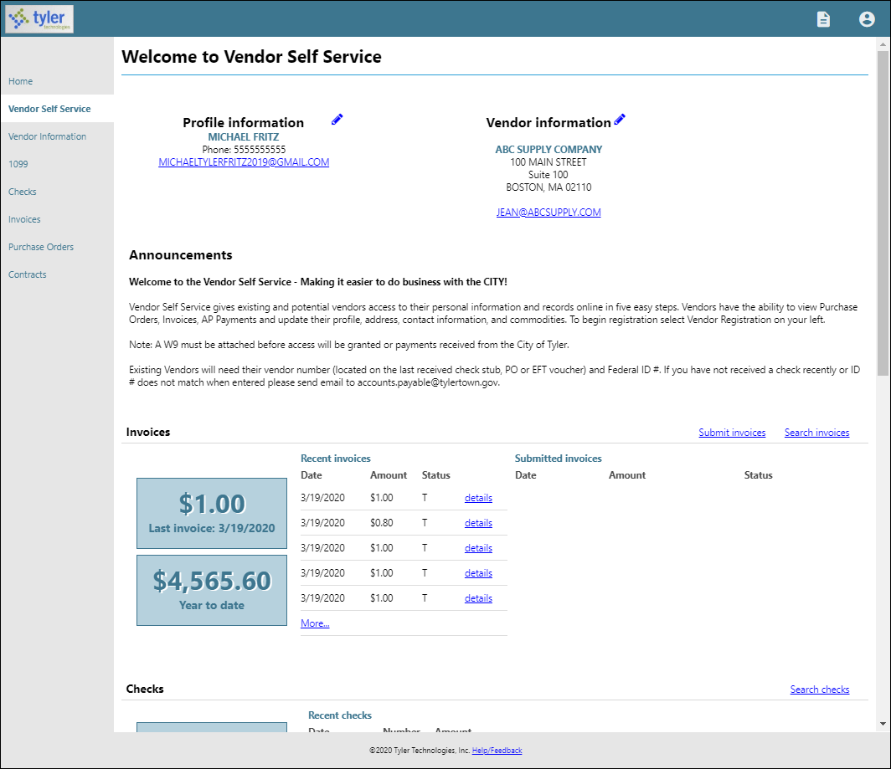

Clicking the login option in the header displays the following menu options:
- Home—Opens the default Self Service home screen.
- My Account—Opens the My Account page containing the vendor’s account information.
- Log Out—Logs the vendor out of Vendor Self Service.
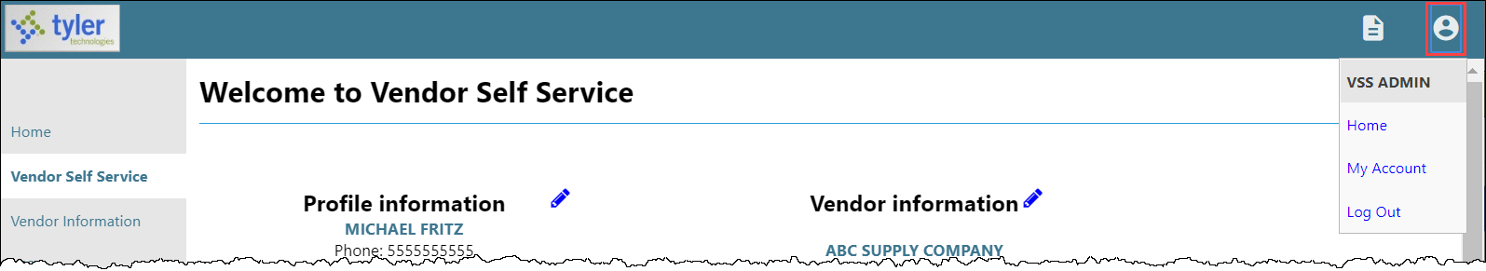
The Resources option in the header provides a menu of links or documents provided by LPPS.
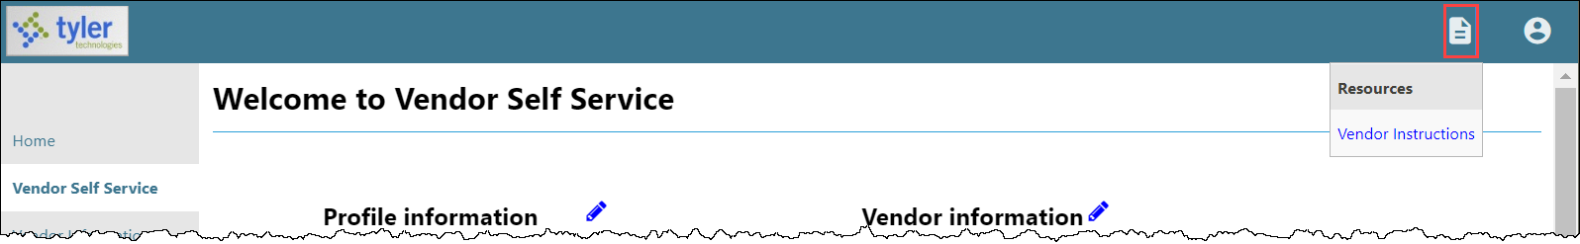

On the Vendor Self Service page, the headings for the individual information groups include options for searching and viewing related information, if enabled by site administrators.
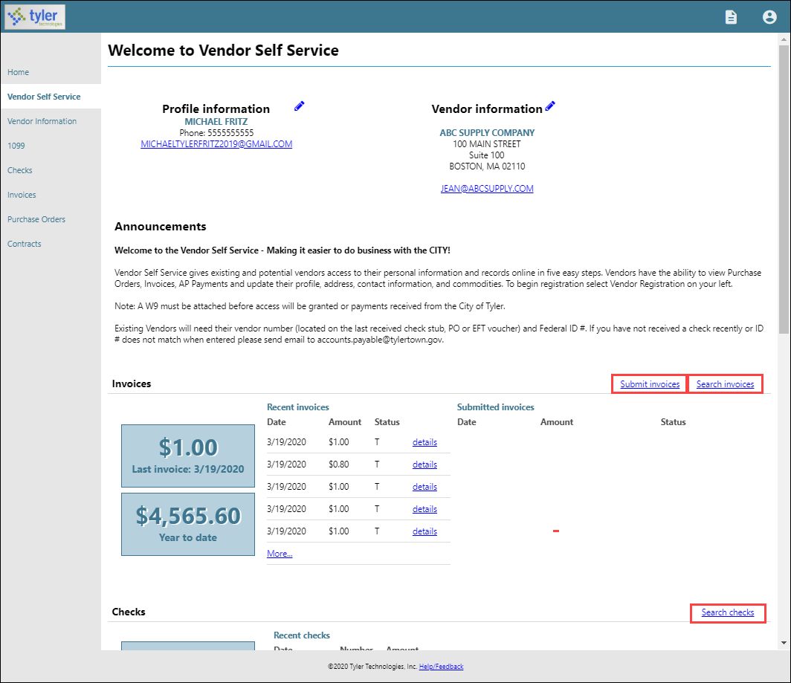

Vendor Information
Clicking Vendor Information provides the Vendor Information page. The Vendor Information page groups profile information by category. By clicking Change, a vendor can update the information in that group.
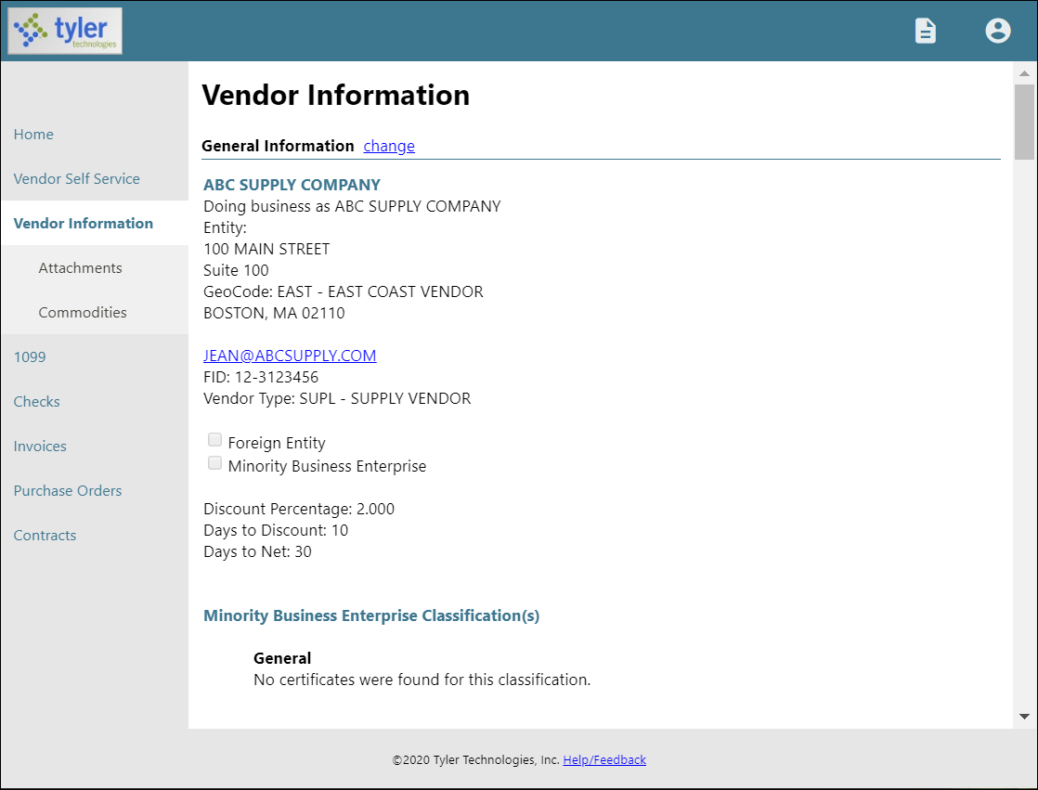

The General Information group contains the vendor’s address and contact information, type and foreign entity status, minority business enterprise status and certifications, and discount terms. If your VSS administrator has enabled viewing of banking information on vendor profiles, the General Information group also displays the vendor’s banking information.

The Address Information group displays the vendor’s remittance address and contact information.
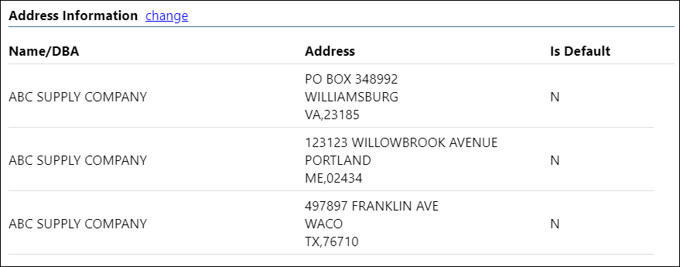
The Contacts group lists the vendor’s contact persons and information.
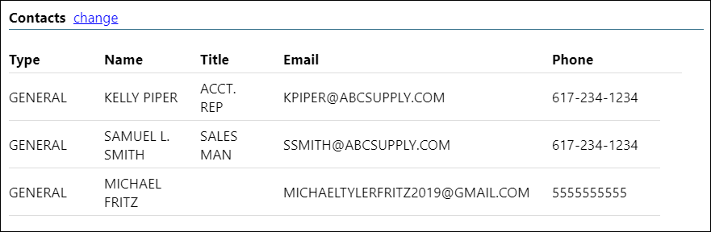

The Additional Fields group identifies the vendor’s shipping preferences. Clicking Change allows the vendor to update this information.
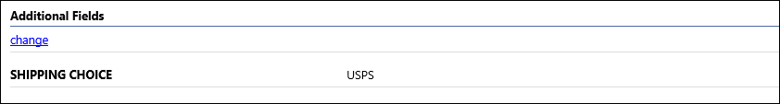
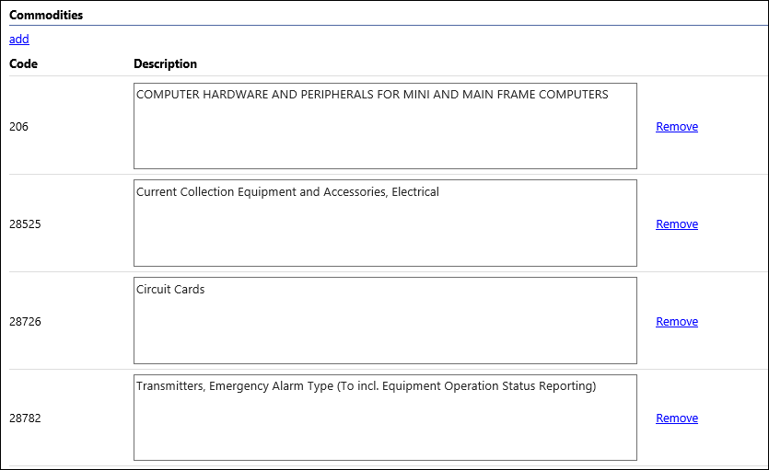
The Commodities group contains a list of commodity codes associated with the vendor. Vendors remove commodities from the list by clicking the Remove link. The Add option allows vendor to add commodities to the list.

Attachments
A vendor adds attachments to their profile by clicking Attachments on the menu. The Attachments option is only available when the vendor is viewing the Vendor Information page.
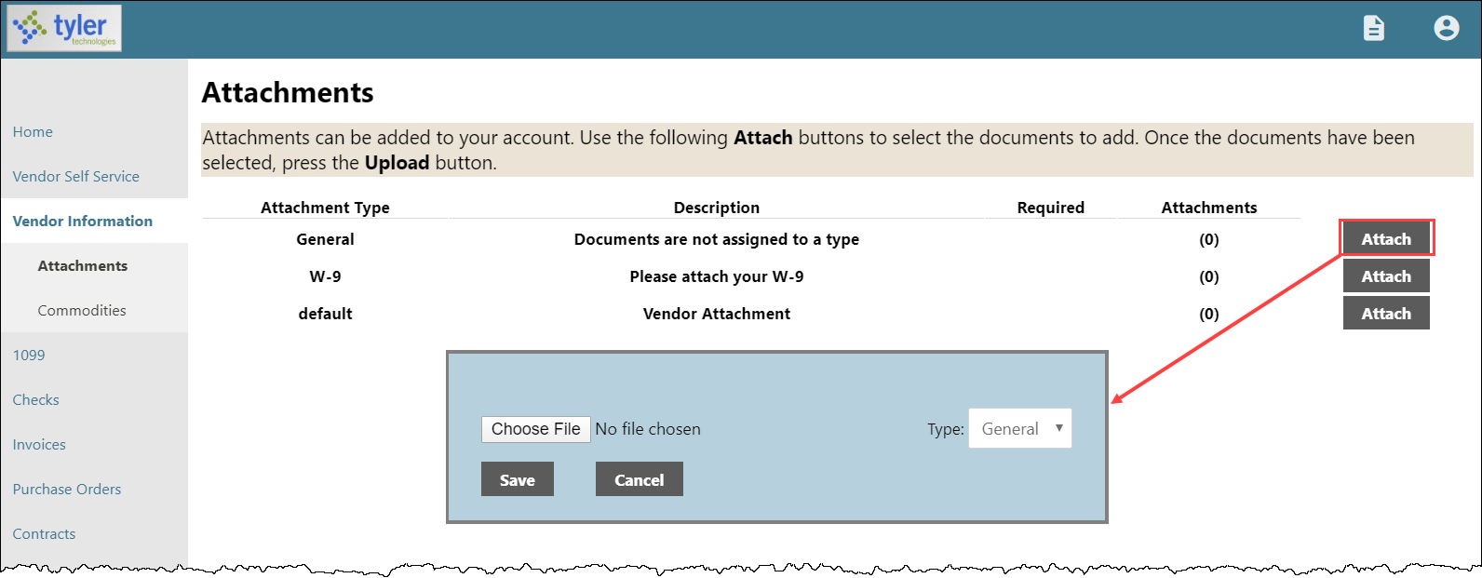

Attachments are added by clicking the Attach button on the Attachments page, which allows the vendor to navigate to a file or document to upload. The Attachments column indicates the number of documents attached for each attachment type. Vendors can attach an unlimited number of files.
Note: Only files with permitted extensions are allowed.

To remove an attachment, click the number in the Attachments column and then select the Delete button for the attachment to remove.
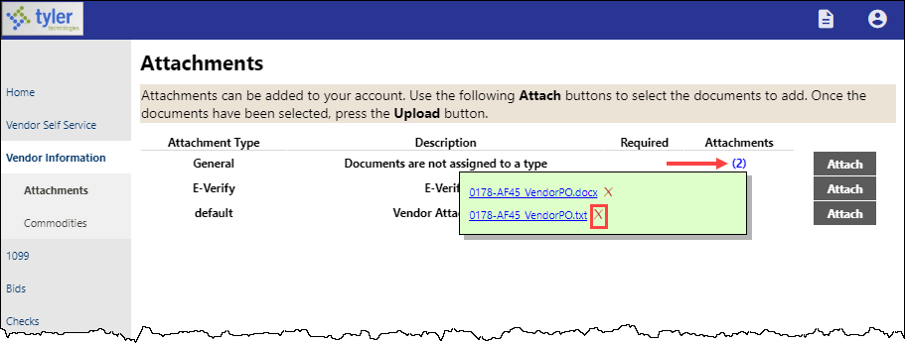
The application displays a confirmation message. Click OK to proceed with removing the attachment.
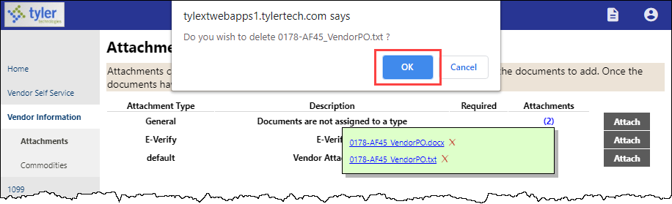

The uploaded files are also added to the vendor record in the Enterprise ERP Vendors program and they can be viewed using the Vendor Attachments screen in that program.

The vendor cannot maintain their attachments in VSS once they have been uploaded. LPPS must access the vendor record in the Vendors program and use the buttons on the Vendor Attachments screen to add, update, or delete the vendor’s attached files.

Commodities
Clicking Commodities on the navigation menu displays the Vendor Commodities page.
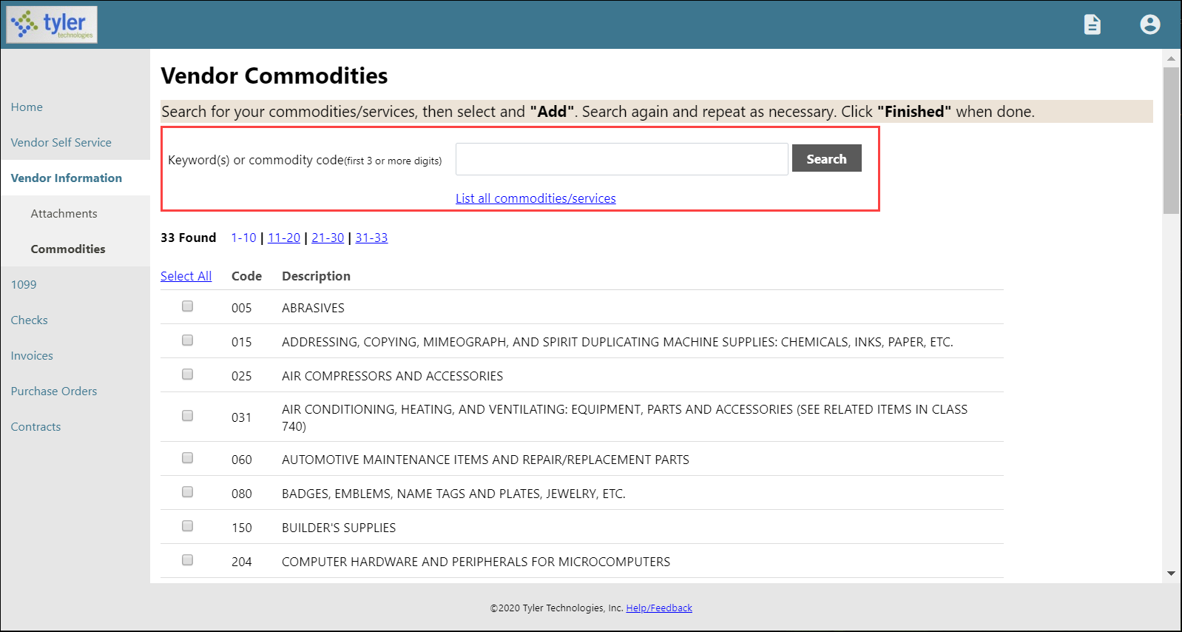

Vendors use the Search box to search for commodities by code or keyword. Alternatively, clicking List All Commodities/Services displays all commodity codes in the LPPS Enterprise ERP database. VSS displays the number of codes found during a search and updates the commodity table.

Vendors can view commodities by group using the numbered group selections, or they can identify specific commodities by selecting individual check boxes. If a vendor selects an individual check box within a numbered group selection, VSS saves the value of each check box when the vendor navigates between the groups of commodity codes.
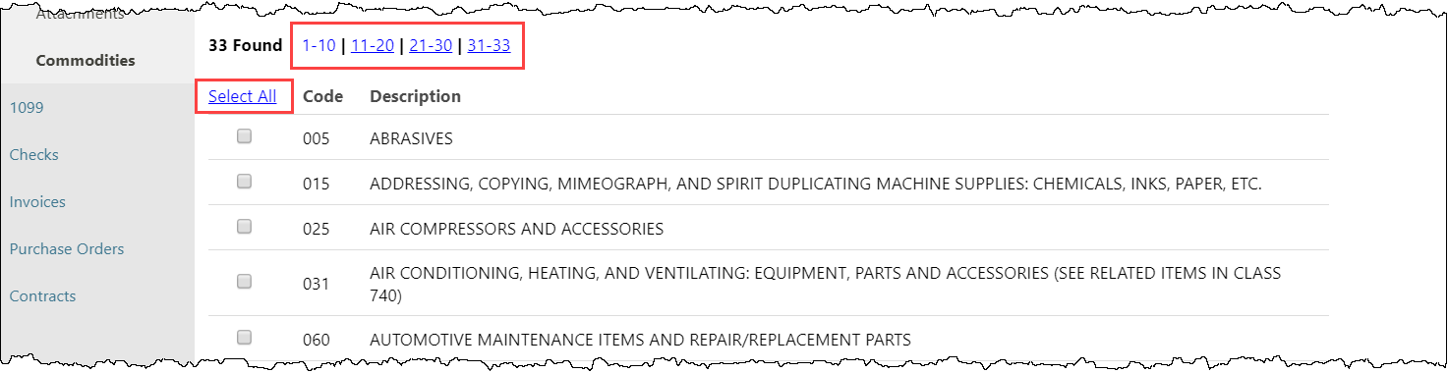

After identifying the applicable commodity codes, clicking Add causes VSS to add the selected commodity codes to the vendor’s profile and updates the list of commodities. Clicking Remove removes the commodity from the group. The Currently Added group provides the full list of associated commodity codes.
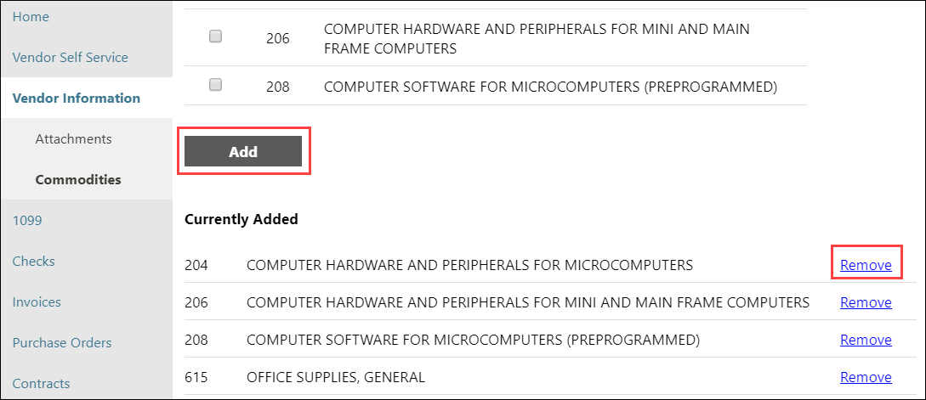
When vendors complete the commodity code update, they click Finish at the bottom of the page to save the changes and return to the Vendor Information page.

1099
The Vendor 1099 Information page displays a listing of the vendor’s 1099 data for a selected year. The data includes the 1099 box code, a description of the code type, and the 1099 amount.
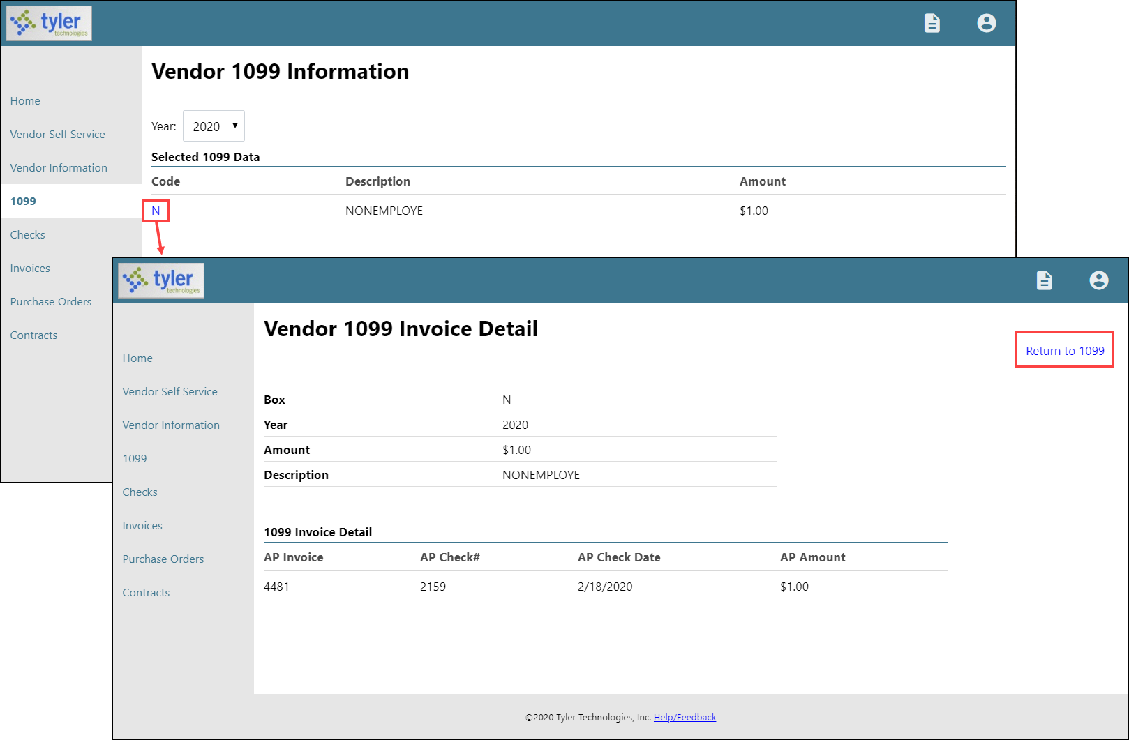

Clicking a code type provides the Vendor 1099 Invoice Detail page. This page displays the general 1099 information, as well as a listing of 1099 invoice details, if they exist for the selected box code. Clicking Return to 1099 returns the vendor to the Vendor 1099 Information page.

Bids
Bids provides a list of bids available to the vendor from LPPS. Bids opens to the Bid search page, which allows vendors to search for bids using the bid number, bid description, or bid status.
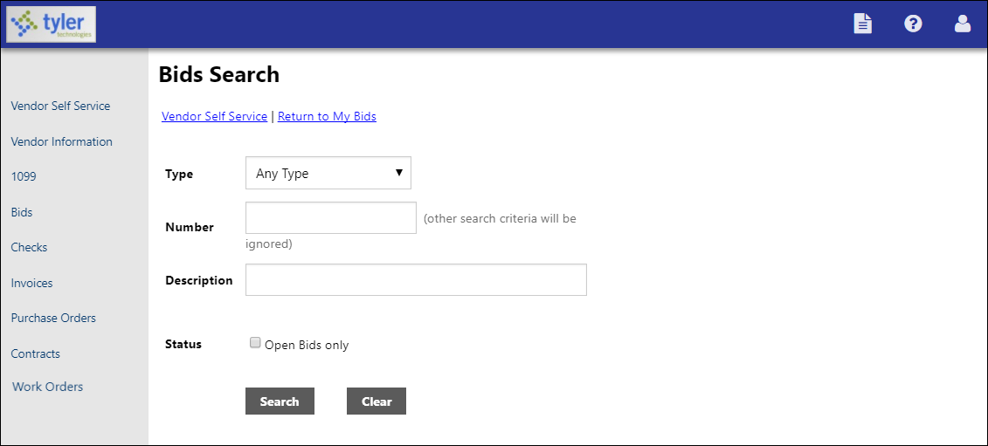

Search results include all bids that match the entered criteria.
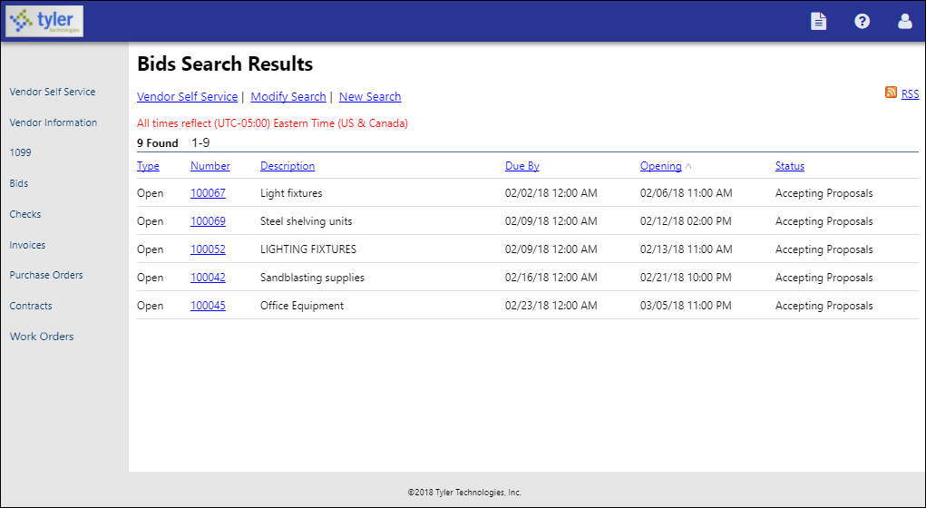
The RSS link allows vendors to subscribe to an RSS feed that is updated when your organization enters or updates bid records.

Clicking the Bid Number for a bid displays the Request for Bids page. The information provided varies according to the current status of the bid. Generally, the Information, Addenda, Items, and Evaluations tabs are available.
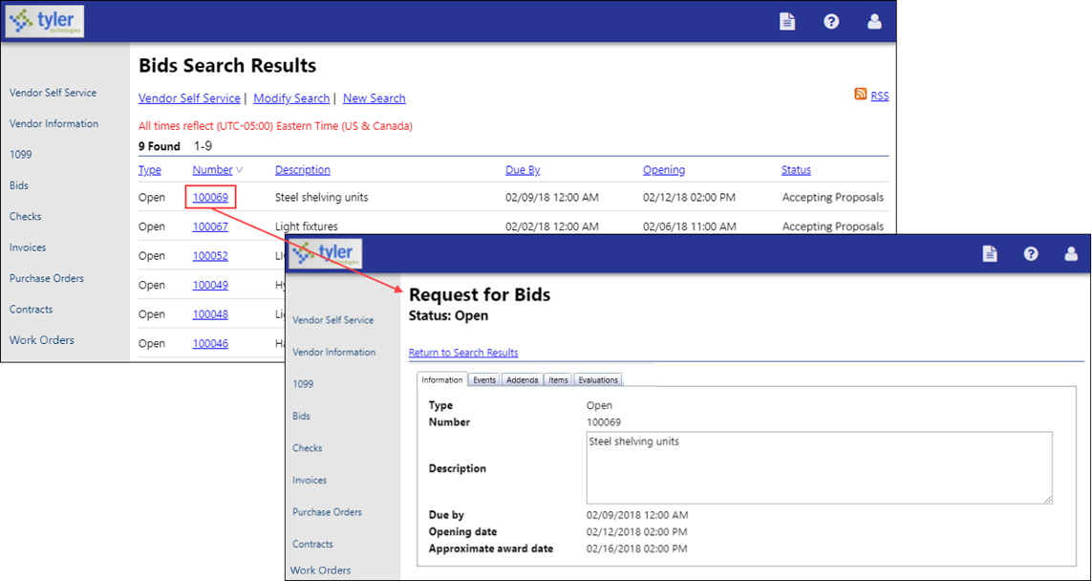

For open bids, the Create Bid option allows the vendor to submit a bid for the selected bid request. The Create Bid procedure is a four-step process that guides the vendor through bid response and submittal.
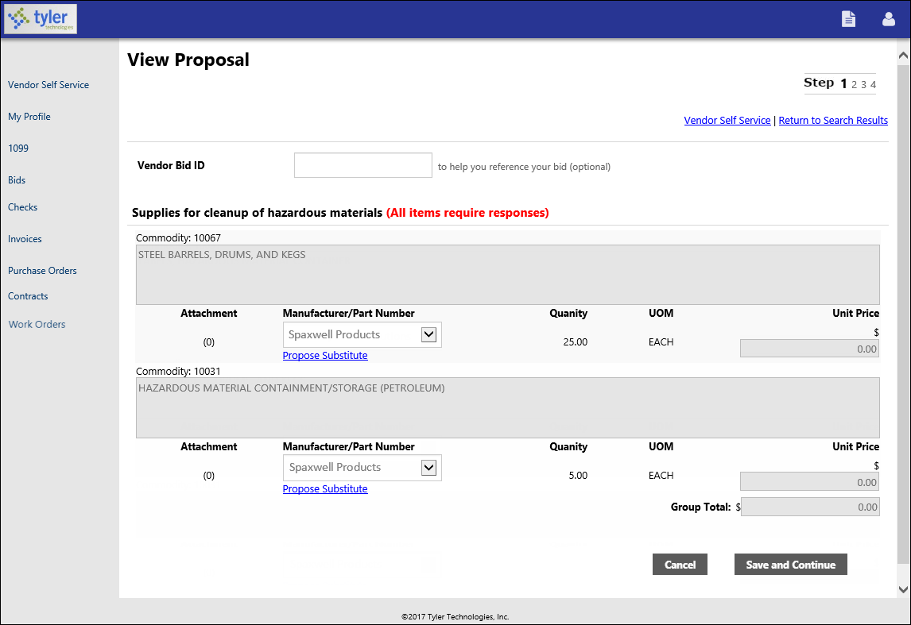

Items listed on a bid display the manufacturer and/or part number if the bid invitation created in Enterprise ERP Bid Central is configured to include this information.

If your organization uses bid bond validation through a third-party bond validation system, the vendor must provide a bond tracking number.
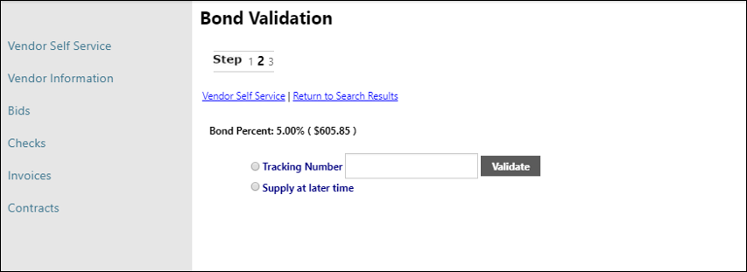

If your organization uses the Allow Substitute option in Enterprise ERP Bid Central, the vendor can propose a substitute item and enter a note justifying the proposed substitute item.
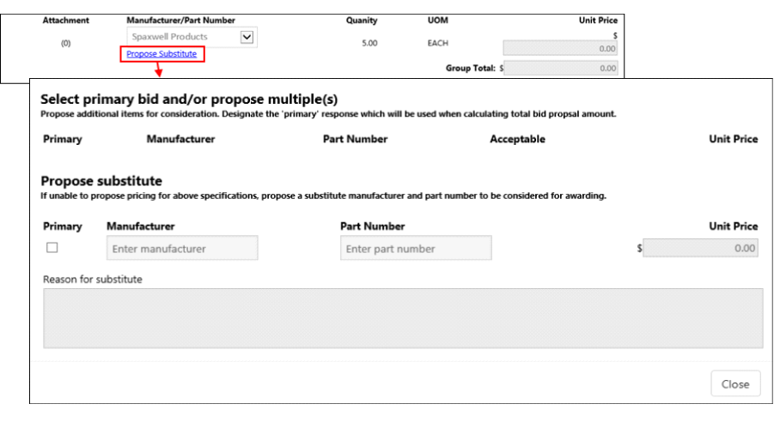
The Save and Continue option saves the information entered and moves the vendor through the steps required to complete the proposal.
The information making up the proposal is organized onto tabs:
- Information—Displays general information about the requestor call for bids.
- Items—Displays the items listed in the request for bids.
- Evaluations—Provides questions to which your organization requires answers.
- Attachments—Stores documents the vendor has attached to their proposal.
Note: The Attachments tab displays only when an attachment has been added to the proposal.
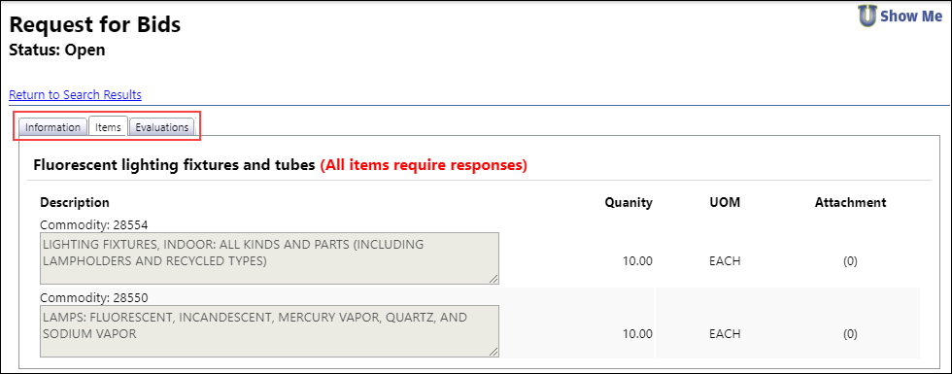

Vendors add attachments to their bid quotes by selecting an attachment type and using the Browse button to select the file to attach.
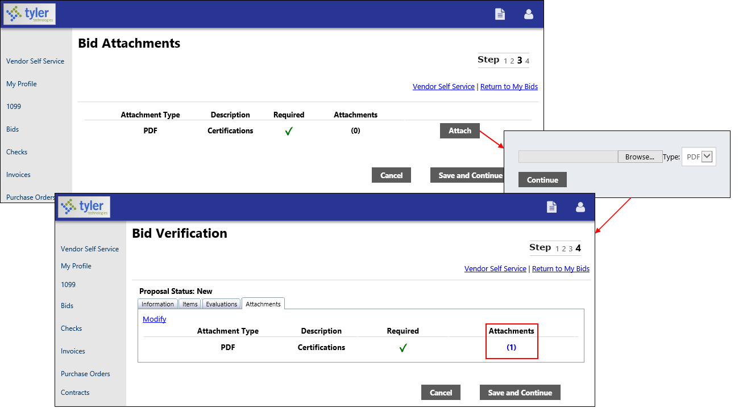

Checks
The Checks group provides a list of checks recently issued to the vendor by your organization.
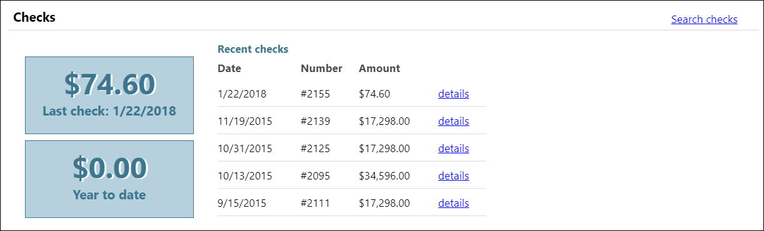

Using the Search Checks option, vendors can find additional check details using the invoice number, date or amount ranges, and status search criteria.
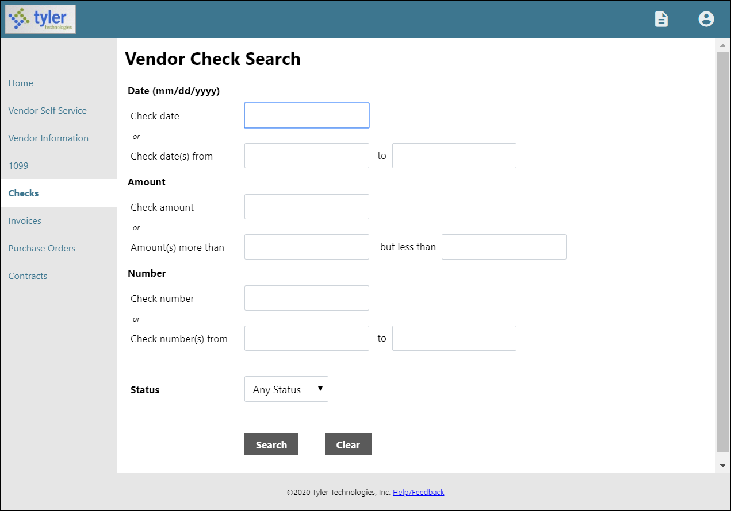

Search Results for checks provides the check date, amount, check number, and status. Clicking a check number reveals additional check details.
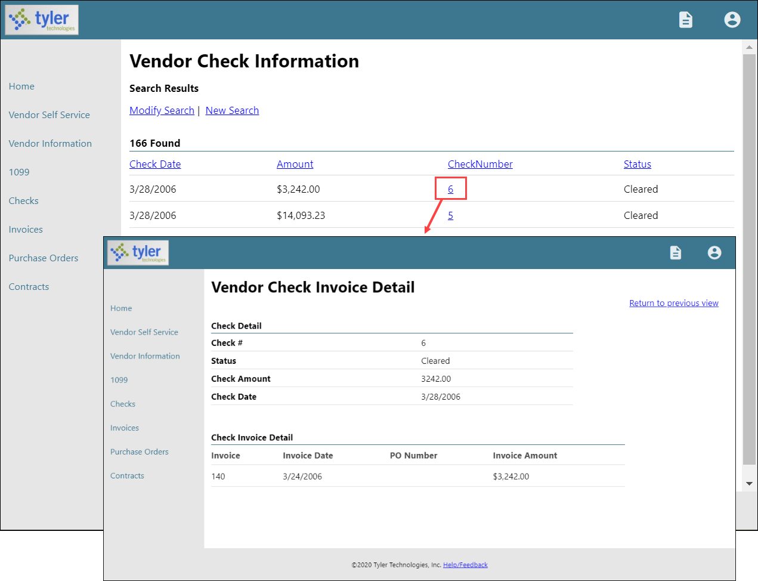
Use the Return to Previous View option to close the Vendor Check Invoice Detail screen and return to the Vendor Check Information screen.

Invoices
The Invoices group provides vendor details for recent and submitted invoices. Vendors are only able to view invoices that are associated with their vendor ID.
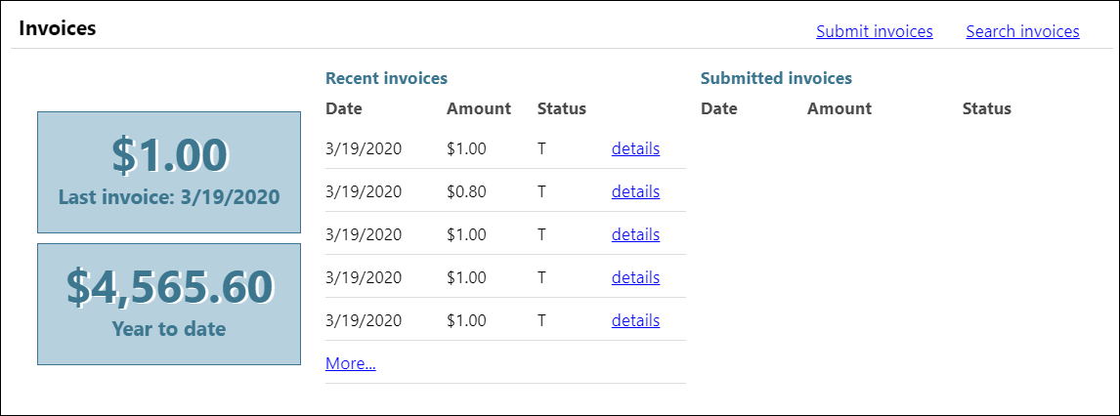

The Search Invoices page allows searches by invoice number, date or amount ranges, and status.
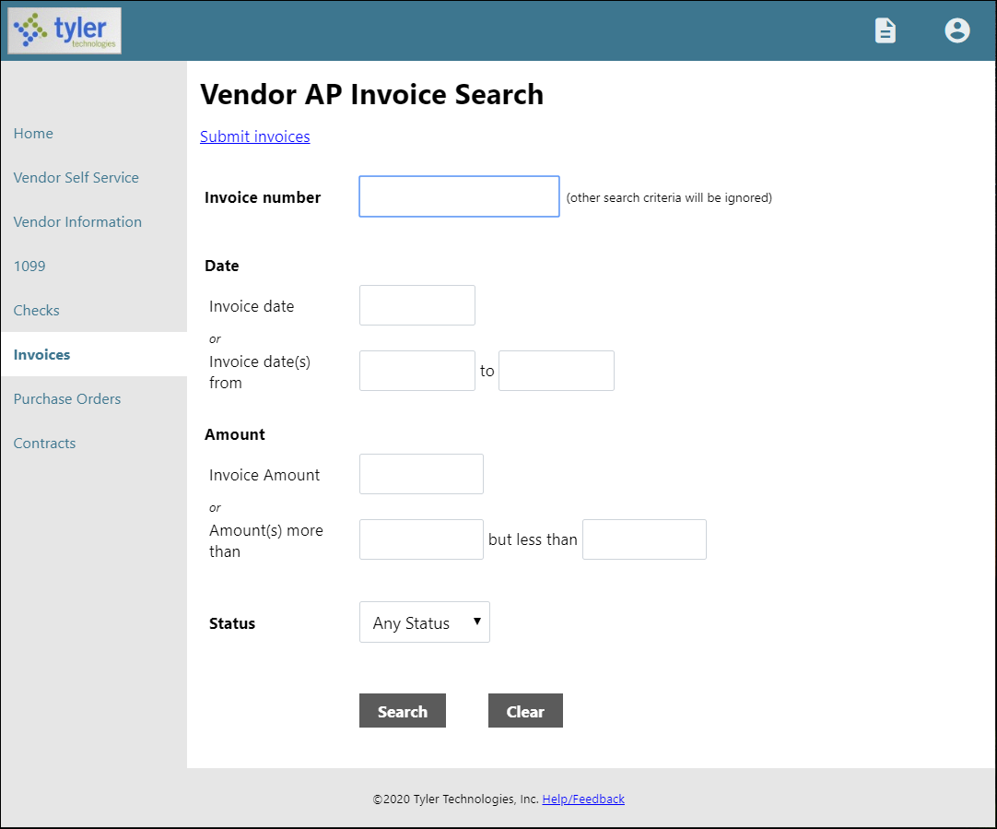

The Search Results page provides the invoice date, amount, invoice number, and status. When the vendor clicks the invoice number, VSS provides the Invoice Detail page, which includes additional information sorted by Vendor, Invoice, and Invoice Totals groups.
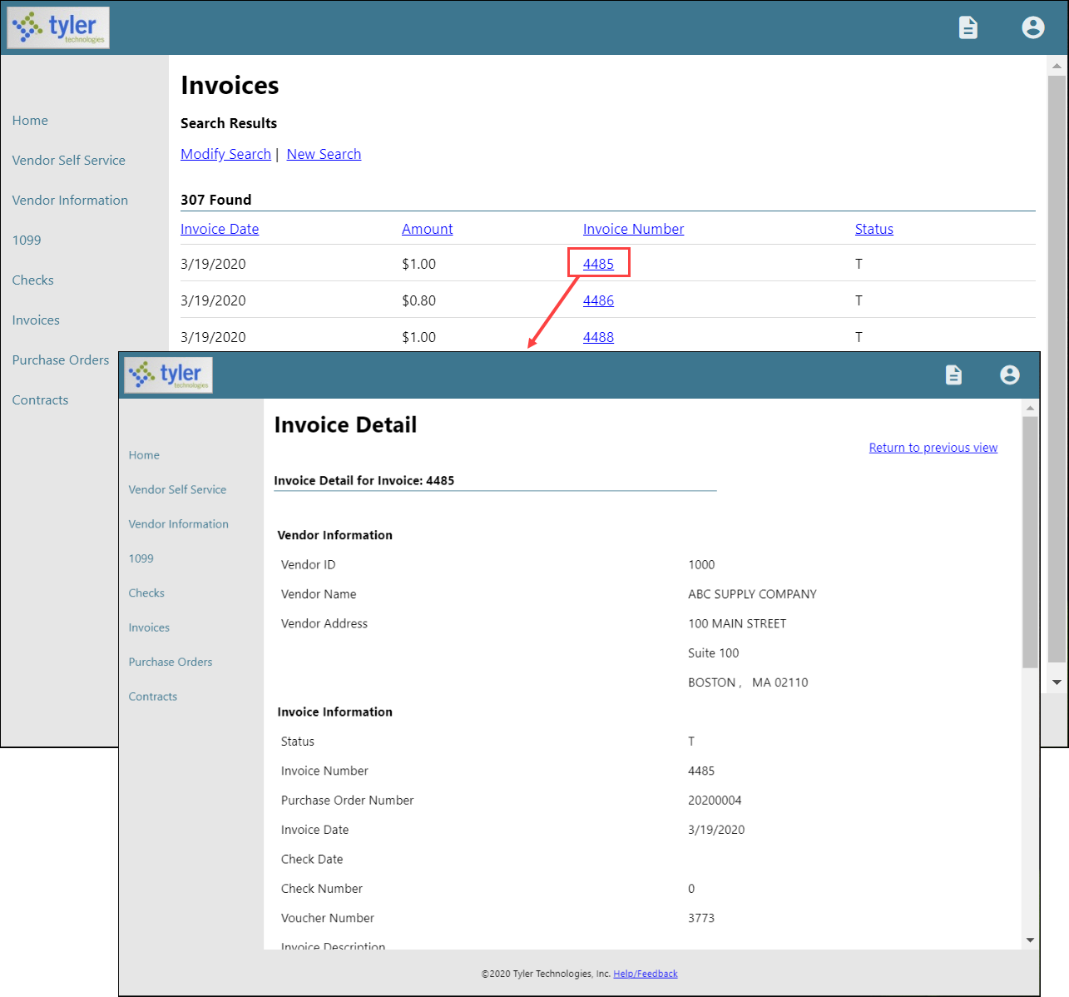

With the applicable settings in Vendor Administration, Enterprise ERP Accounts Payable Settings, and Enterprise ERP Purchasing Settings enabled, the Submit Invoices option allows vendors to submit invoices to your organization directly from VSS.
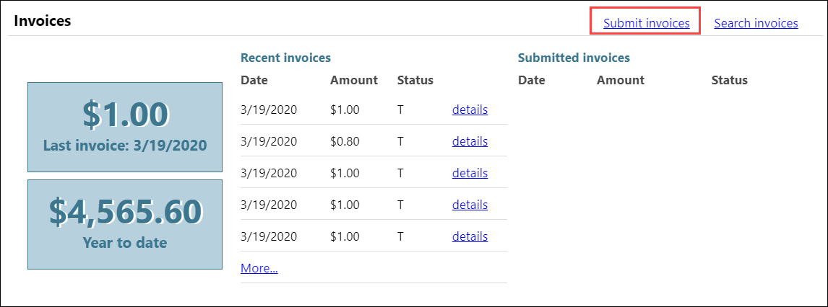
Depending on settings configured for the vendor, the Submit Invoices option may require the vendor to indicate a valid purchase order or contract number when they submit an invoice.

Purchase Orders
Purchase Orders provides a list of recent purchase orders issued to the vendor from your organization.
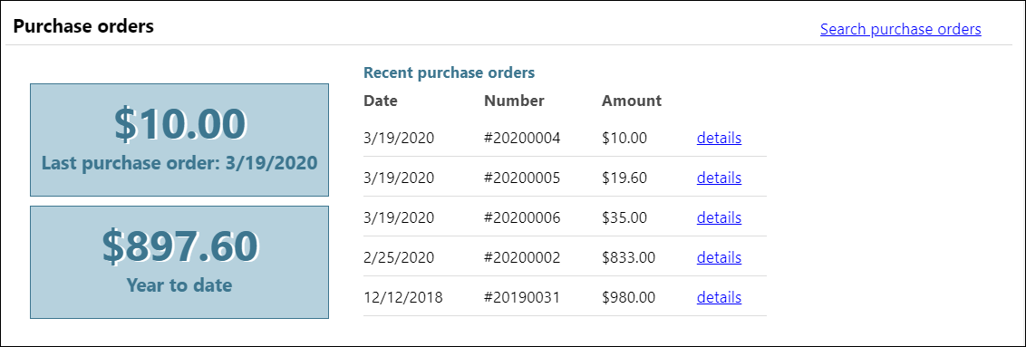

The initial Search Purchase Orders page allows vendors to search by purchase order number, date, or a purchase order total range.
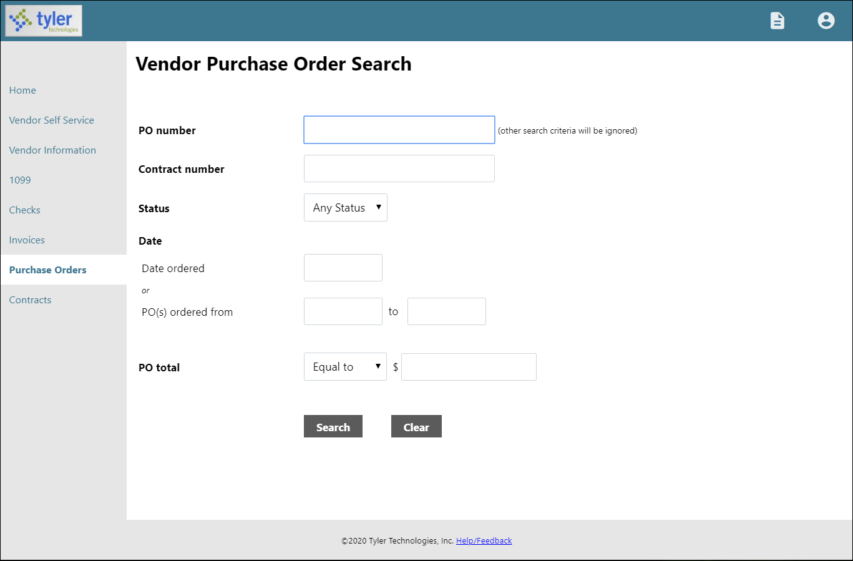

Search results include the purchase order number, contract number (if applicable), status, date orders, and total. Clicking a PO number provides additional details for a specific purchase order.
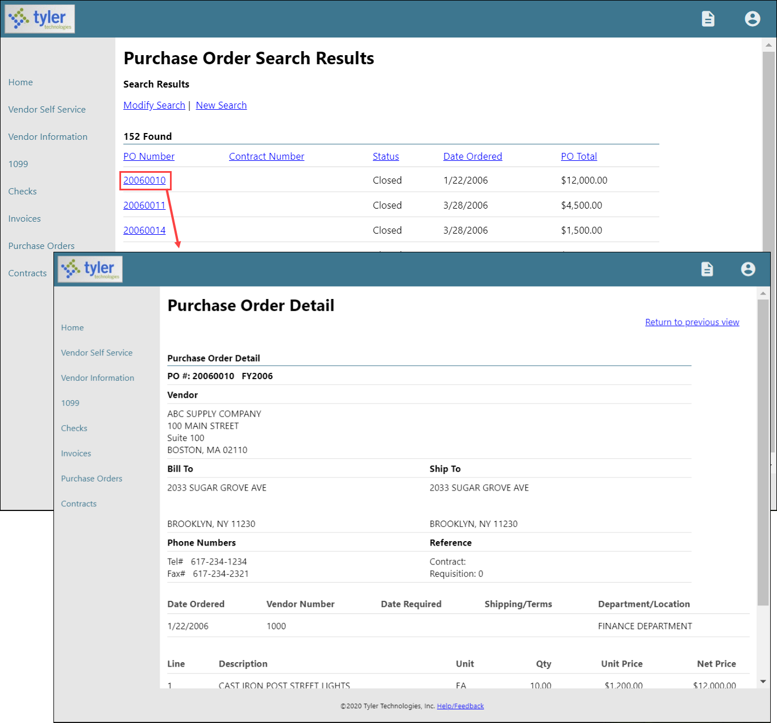

Contracts
Contracts provides contracts the vendor currently holds with your organization.
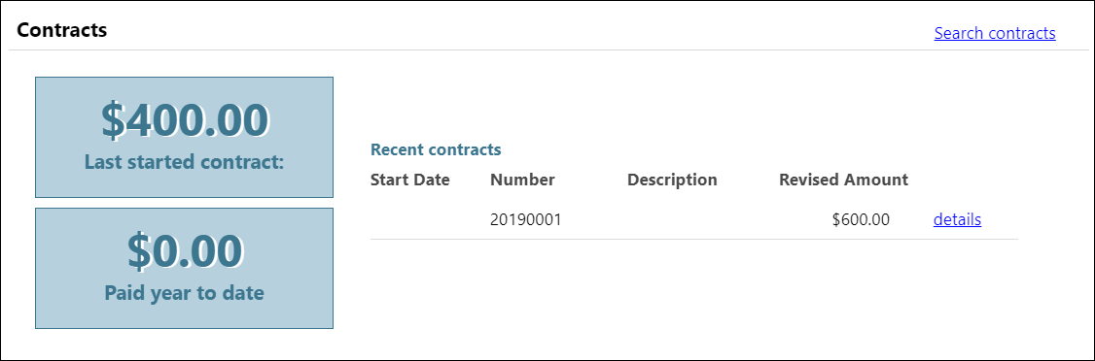
The initial Contracts Search page allows vendors to search by a range of contract numbers or years.
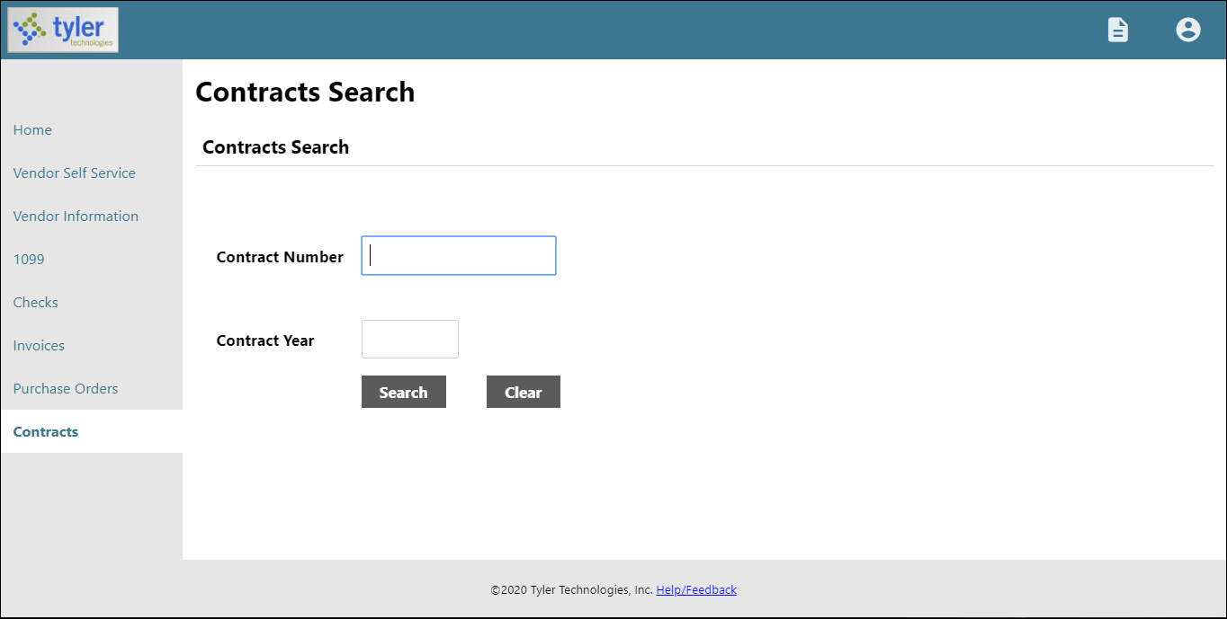

Search results include the contract start date, number, and amount. Clicking a contract number shows the Contract Detail page for the selected contract.
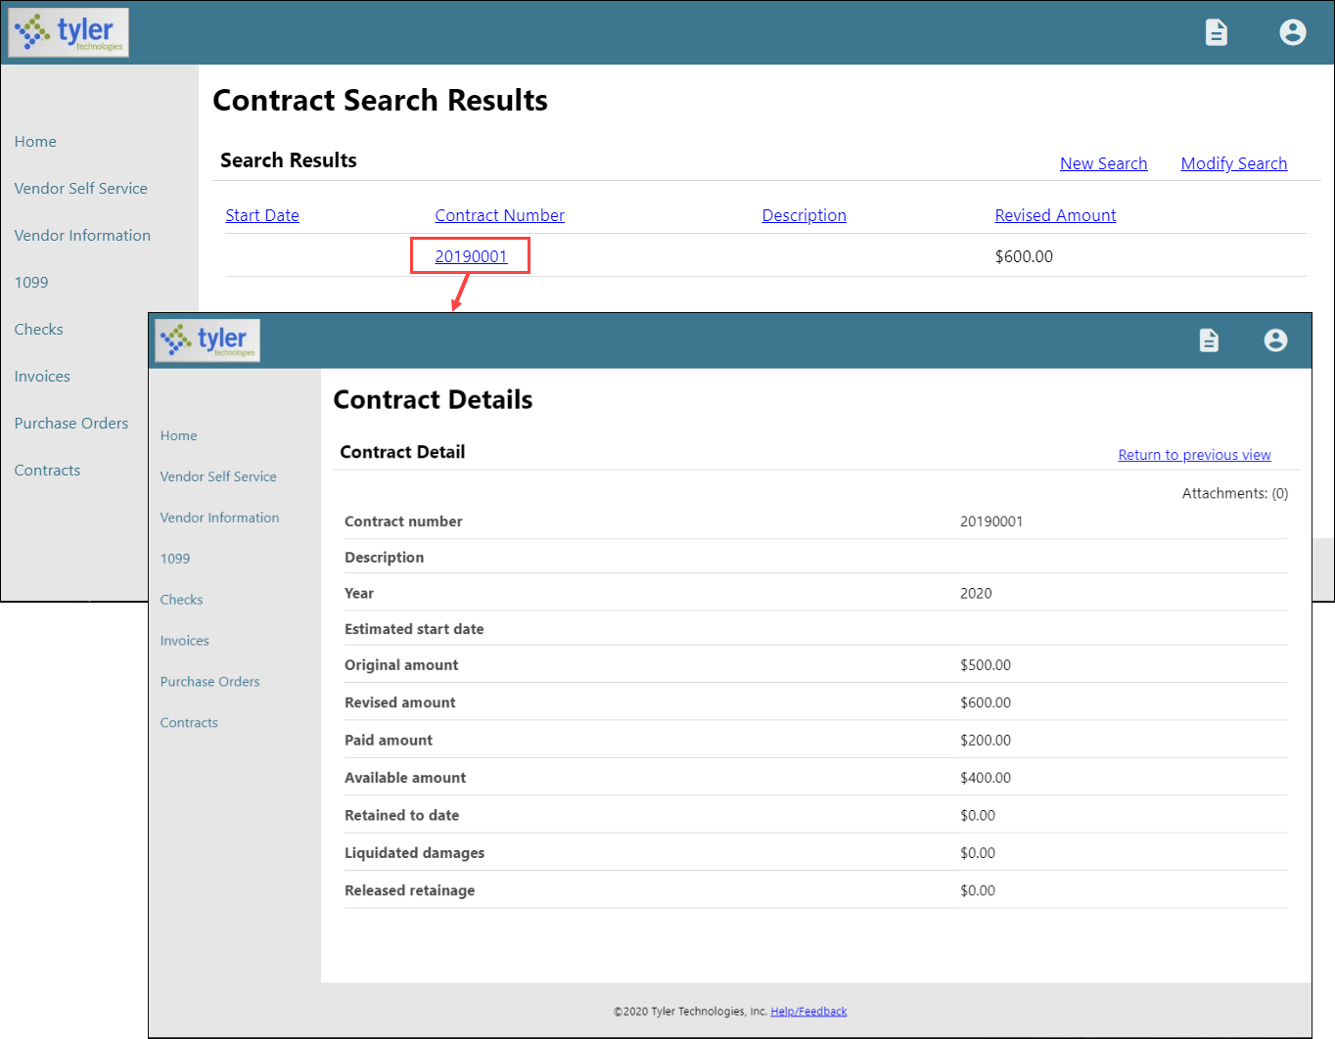

Work Orders
If LPPS uses Enterprise Asset Maintenance (EAM) and has the optional Asset Performance features enabled, LPPS can assign work orders to vendors.

The vendor can view their work orders on the VSS Work Orders page.

The initial Work Orders Search page allows the vendor to search by work order number, activity, description, or a range of creation dates.
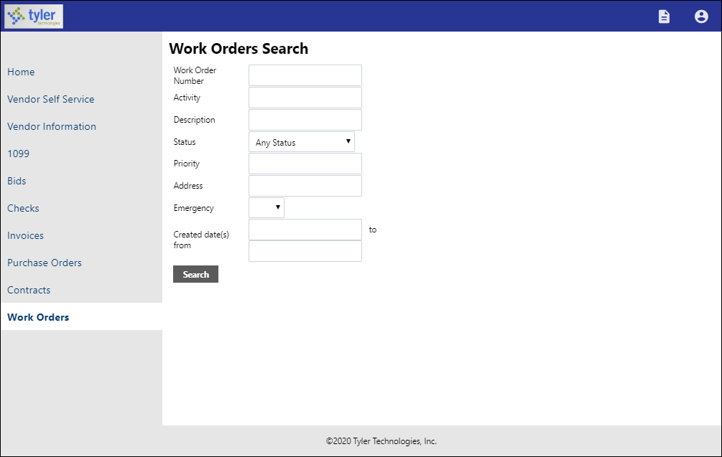

Search results include the work order number, activity, description, department, status, priority, address, emergency, and created date. The Details option displays the Work Order Detail page for the selected work order.

Appendix A—Managing Minority Business Enterprise Certificates
To maintain MBE certifications, vendors use the Change option on the Vendor Information page.
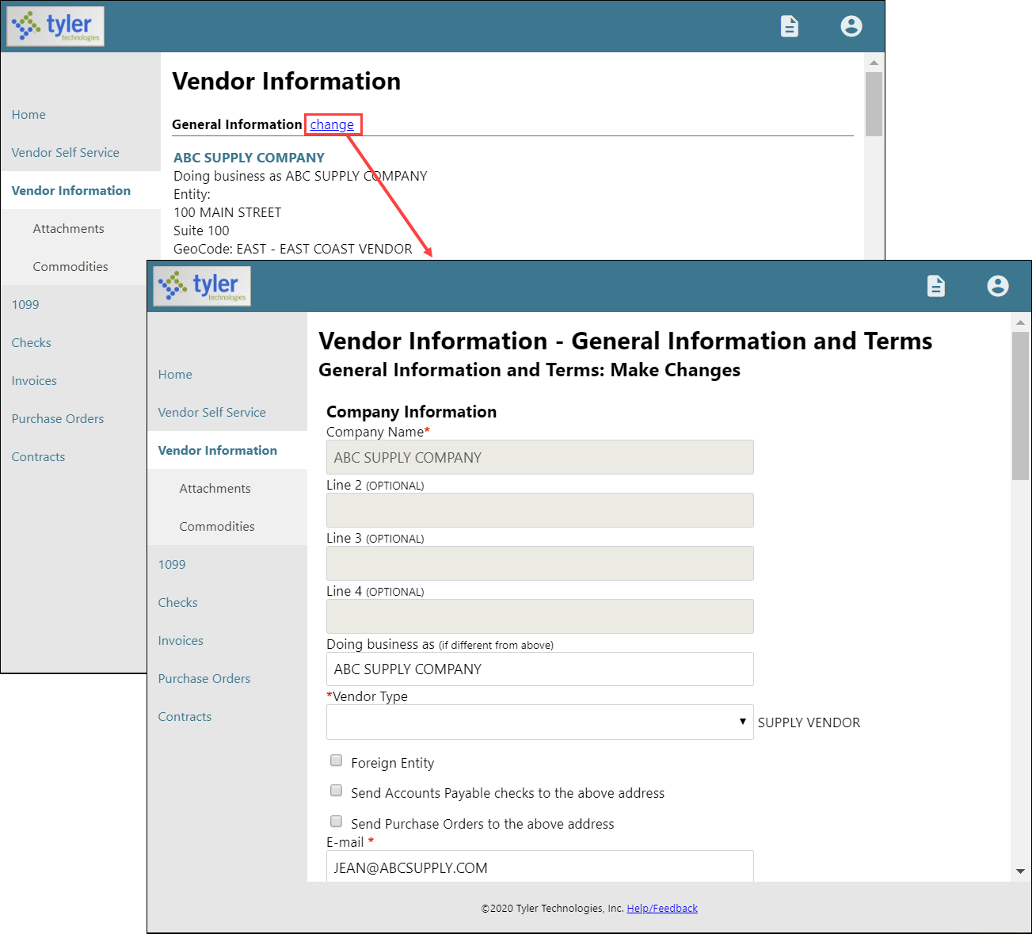

The Minority Business Entity (MBE) section contains the check boxes that indicate if the vendor is a minority business enterprise, and if so, which classifications the vendor possesses.
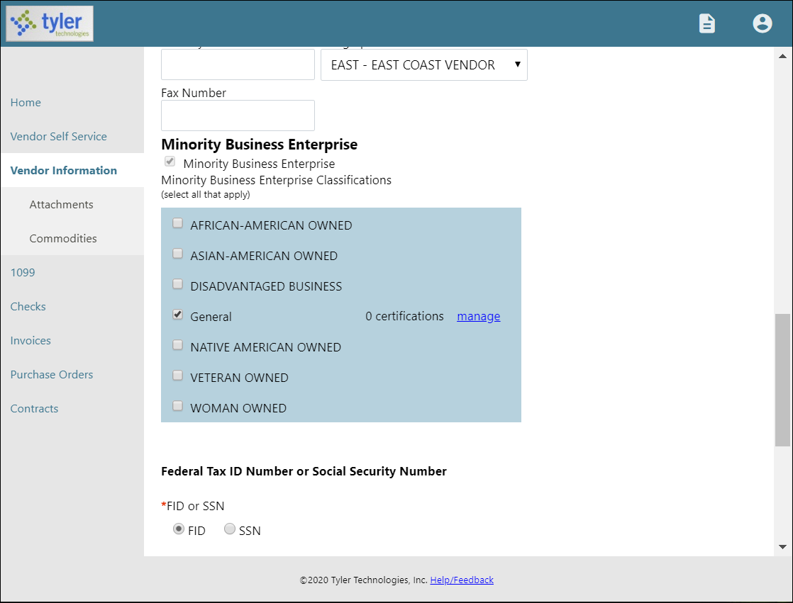
The Manage option for each classification allows a vendor to maintain the classification using the Manage MBE Classification Certificates page.
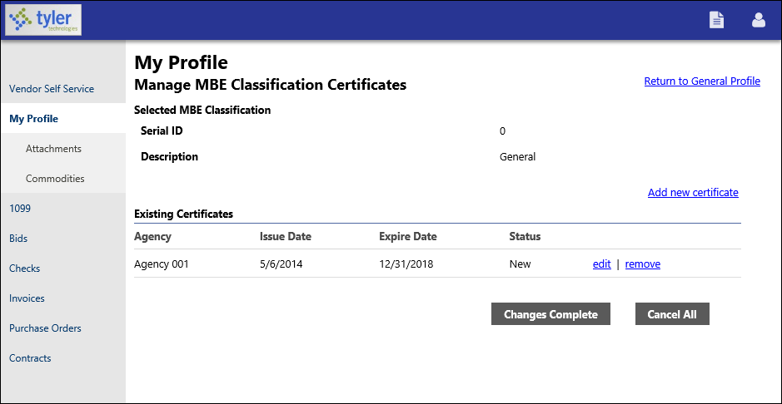

Clicking Add New Certificate refreshes the page to include the Certificate Details section. For new certificates, the vendor must complete the Agency, Issue Date, and Expiration Date fields. 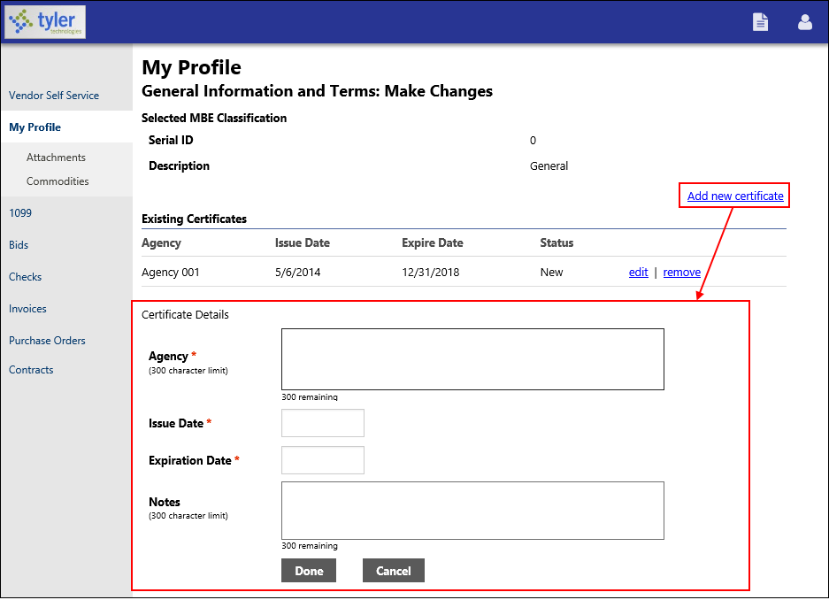
When the vendor has finished entering data in the boxes, clicking Done saves the entry and displays the Make Changes page.
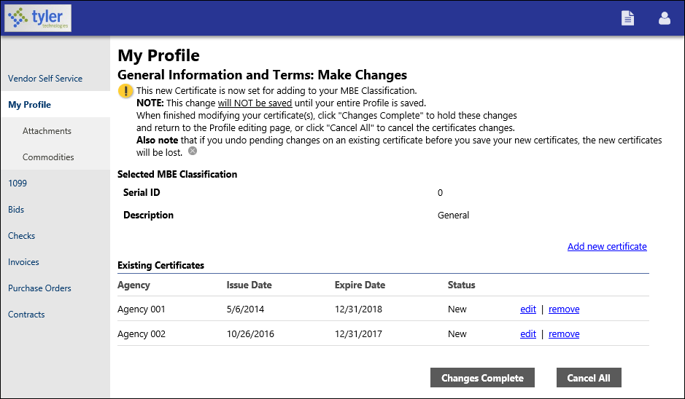

The Make Changes page includes a message indicating that the new certificate is ready to be added to the vendor’s profile, but that the information will not be saved until the vendor’s entire profile is saved.

After entering, editing, or removing certificates for a classification, the vendor clicks Changes Complete to save the certificate entries or Cancel All to discard all of the certificate information. Clicking Changes Complete returns the vendor to the Make Changes page, where the Minority Business Entity section displays the updated certification count.

On the Make Changes page, the vendor must click Update to permanently update their profile with the certificate information.
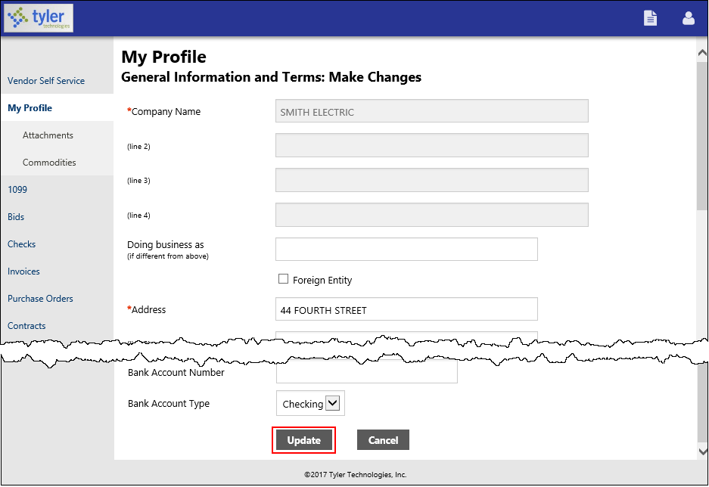

Appendix B—Using Vendor PIN Authentication
Enterprise ERP provides an additional option to configure multifactor authentication when a new user attempts to link to an existing vendor in Vendor Self Service. When this setting is enabled and a new user in VSS tries to establish a link to an existing vendor, the system sends an email with a unique PIN to the main vendor contact email address established in the Vendors program. The user cannot proceed with the registration in VSS until the vendor provides the PIN to them. The PIN can also be accessed by LPPS and supplied to the vendor as needed to validate the link.

- In Vendor Self Service, a new user attempts to link their user ID to an existing vendor.
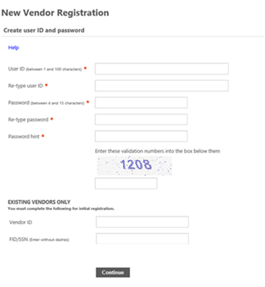
- When the user enters contact information, VSS creates a new contact record.
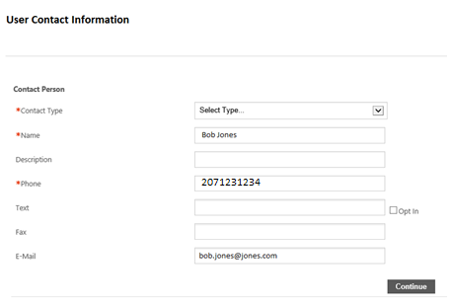
- When PIN functionality is enabled, the user cannot proceed with linking the vendor until they enter a validation PIN.
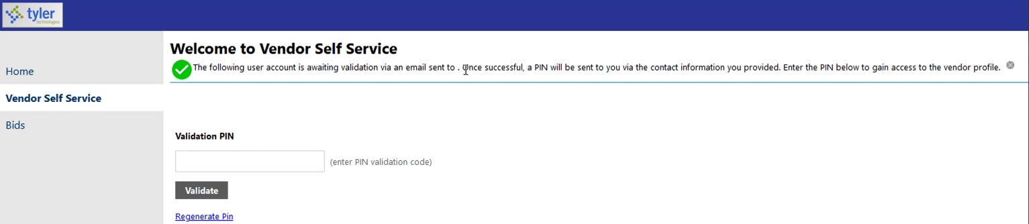
Note: The user cannot see any linked vendor information until they successfully enter a valid PIN.
- Meanwhile, the system generates a PIN for the vendor/user combination and sends it to the email address identified on the Main tab of the vendor record in the Enterprise ERP Vendors program.
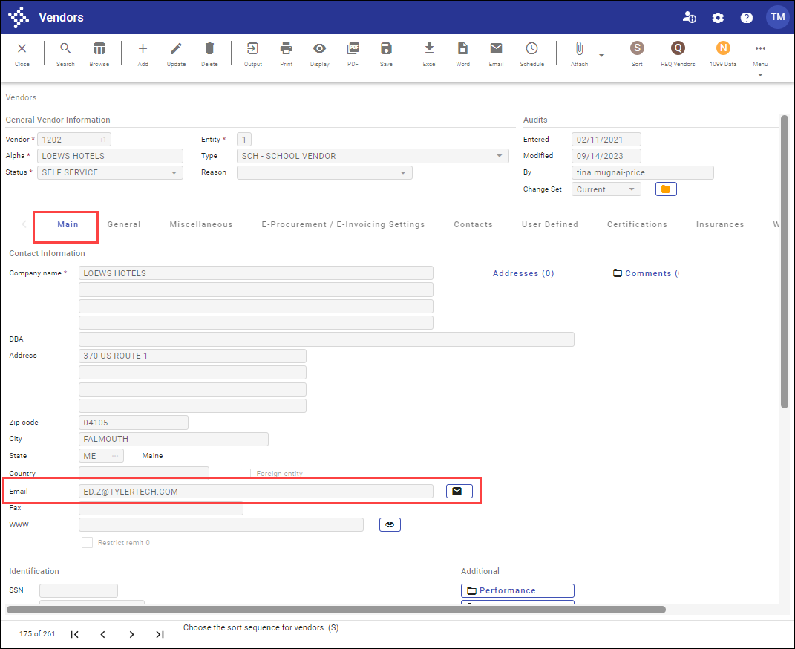
Example Email
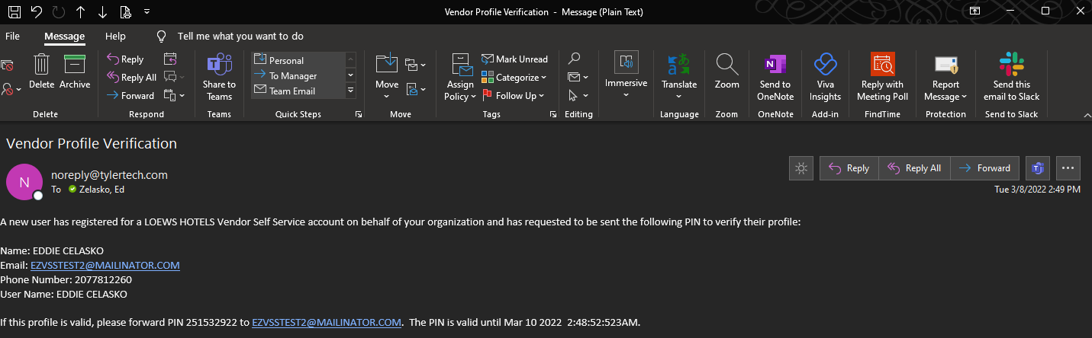
A new user has registered for a <Vendor Alpha Name> Vendor Self Service account on behalf of your organization and has requested to be sent the following PIN to verify their profile:
Name: <User First and Last Name>
Email: <User Email>
Phone Number: <User Phone Number>
User Name: <Username>
If this profile is valid, please forward PIN ##### to <User Email>. The PIN is valid until <Date> <Time>.

- The vendor contact who received this email can then forward the email with the PIN validation to the user who attempted to link to the vendor, or provide the PIN verbally to the user.
Important: Vendors must be sure to properly authenticate the user to whom they are providing the PIN. Once the user is linked to the vendor, the user can access and maintain all vendor information through VSS.
- The generated PIN is valid for 36 hours. If the PIN expires, the user can click the Regenerate PIN option in Vendor Self Service to send a new unique PIN email to the vendor contact identified on the Main tab in Vendors.
- Once the user enters the valid PIN in VSS, they are verified and linked to the vendor.

